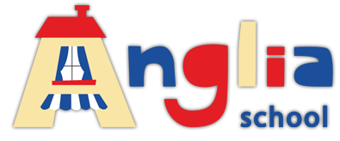
ASSOCIATION EUROPEENNE DES ENSEIGNANTS Anglia School
Section bulgare
Европейска асоциация на учителите ул. Родопи 88
Българска секция Пловдив 4000
ПК 57, София 1797 info@anglia-school.info
тел: 0883504664; 0898489699 тел: 0894323001

FACT training seminar for teachers in Content and Language Integrated Learning
11 November 2017, Plovdiv
Programme

11.00 – 12.30
Introduction – Keith Kelly and Stefka Kitanova
Example activities – Geography and History in language and language in Geography and History - Keith Kelly
Example activities – Natural Sciences: Biology, Chemistry – Stefka Kitanova
12.30- 13.00 break
13.00-14.30
Project work
Trashedworld: A Schools' programme on waste and sustainability – Keith Kelly
SAW: Science Across the World programme of investigations for schools' exchanges – SK
Other projects – experience, ideas, etc.
Planning for future meetings, closing words

Location - Anglia School, 73 Kapitan Raicho St, Plovdiv

For participation please confirm by phone or email. Limited spaces available free on a first come first term basis.

