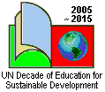

James Hindson
Aleksandra Zaparucha

Education for Sustainable Development in an English classroom – part 3
Is there a solution?

It appears that much of what we are doing in our environmental action is not going to lead us to a sustainable planet. At best a lot of what we do is “action for a slightly less bad world” in the future. In addition, the actions we often encourage young people to do often are highly unattractive to a generation that judges itself by how much of the right stuff they own or wear! Asking them to cut down consumption seems like a step backwards.

Is there a better way forward? Thankfully many businesspeople and politicians are beginning to think so and the activities in this article will help young people understand some of the key ideas behind a few of the better solutions for sustainability.

The main activity in this article involves taking young people outside to some part of nature, preferably where they can look at trees in woodland. It does not have to be a wild area – a nearby park or field or even a green part of the schools grounds will do. If you are not used to taking young people outside for learning you can find plenty of advice on this website – www.lotc.co.uk.

If taking your class outside is difficult then you can use large images of a nature such as the picture of the trees included as Resource A or you can google other images of trees and woodlands if you don’t like this!

Activity 1
Learning from Nature

Divide the class into groups of three or four and ask them to look at the natural area they are in. The groups should each have a clip board, some pencils and plenty of sheets of A3 plain paper!

Step 1
Ask the group to draw a quick sketch of the tree they are looking at. The diagram should be labelled in English with at least five different parts of the tree and the area around the tree that they can see. You can suggest that they can add a few living creatures (though not humans!) even though perhaps they can’t see them as they know they must be there. You can review the diagrams in the field correcting spelling and adding vocabulary as needed.

Step 2
When the groups have sketched and labelled their tree, gather them together and give them a copy of the Resource B and ask them to go back to their tree and answer the questions.

Go through the questions to clarify what each one means. Here are some points to help you!

- Waste. Ask the groups to identify any natural waste they can see and mark this on their diagram. If they look puzzled you can have a short discussion about what they might be looking for and how they define natural waste. Answers might include dead leaves, twigs that have fallen from trees, flowers, and, of course, waste from animals (be prepared for some interesting words in English!) and dead animals.
- Source of energy. To some extent, energy is tied up in the food but the overall source of energy for the whole system is the sun. This is used by leaves in photosynthesis. None of it is wasted!
- Food. Principally a tree derives food from nutrients in the soil that are taken up through the roots. Some of the more aware pupils might add the fact that some of the nutrients will come from the decaying natural “waste”.
- Water. When rain falls it falls into the soil around the tree where it then helps in the decomposition of leaves, animals and so on. It also then absorbs nutrients from the soil and is taken up by tree as food and water.
- Toxics. There are really no toxic or poisonous things in nature. It is true that some fungi might be poisonous for humans but this is for protection. This is quite a difficult question!
- Functions. A tree has many functions – these are sometimes called ecosystem services. A tree

- protects the soil holding it together by it’s roots,
- is the home or shelter for many animals, insects and birds,
- provides food for different animals and sometimes humans,
- absorbs CO₂ and gives out O₂ to contribute to the balance in the atmosphere,
- retains moisture in the soil for other plants,
- is beautiful to look at and gives pleasure,
- and the pupils might think of others!

Hopefully their diagrams might look something like completed Resource C, though it is important to realise that there is no completely right or wrong answer. The more perceptive groups will notice that there are a number cycles in this natural system. For example, waste decomposes over time and forms food for the tree and other parts of nature.

Step 3
Back in the classroom you can give the groups a copy of Resource C to complete. This diagram is a prompt to help the pupils analyse their observations. The right answers are provided below the diagram.

As a homework task you can ask your pupils to complete the table in Resource D. This compares the human systems that they looked at in the first lesson on ESD with the natural systems they looked at on the fieldwork activity.
The key points to summarise through these activities are that the natural systems work very differently from human systems. Human systems are really waste producing systems whereas in nature “all waste is food”. Human systems waste valuable non-renewable energy. Natural systems work just using renewable energy.

Activity Two
Is it possible in real life?

The activity can start with a challenge. Is it possible to make the things we need using “lessons from nature?” Can we redesign our human systems so that they work like natural systems? Instead of the “Take, Make and Waste” system the previous article considered, can we instead create systems where all the biological things have been designed to be put back into nature instead of being thrown away. Can we create a system where all the non-biological things, such as metals and plastics, are designed to be reused in other products?

The answer is “yes” and there are some businesses that are doing it already! Some of them are working on a larger scale and others on a smaller scale. A lot of legislation from the European Union is making businesses design products, like mobile phones, so that they can be taken back by the company when the consumer has finished with them and then the company reuses the components.

The diagram in Resource E summarises the key points.

Step 1
This activity looks at a small scale example.

Divide your pupils into small groups and give each group the data in Resource F. Ask them to imagine that the will be interviewing the Director of the company producing these raincoats and they need to make a list of between five and ten questions they would ask him or her.

Step 2
Ask you students to look at another product – such as an item of clothing bought from a local store. They should draw two diagrams. One they should label to show how the current product is unsustainable. Then ask the students to draw another version of the product to show what needs to be changed to make the product a really sustainable or ecological product.

Suggestions for follow-up activities

As a follow-up summarising all the lessons on ESD you can give your students some of the following tasks in order to boost their language skills and revise what they have learnt on sustainability.

Divide you class into groups of 3 or 4 and ask them to select a topic for further research. Ask them to give a short presentation on the given idea.

- Bikeability Checklist: How bikeable is your community?
http://www.bicyclinginfo.org/pdf/bikabilitychecklist.pdf

- CO₂nnect: CO₂ on the way to school
http://www.co2nnect.org/

- Ecological Footprint Calculator
http://www.ecologicalfootprint.com/

- Global sustainability
http://www.globaldimension.org.uk/

There are lots of good resources on You Tube – just google the subject you are interested in and you will usually find some interesting presentations that can work with your pupils. A good example is this short film from Green TV:
http://www.green.tv/wwf_oneplanetfuture

You can also use these websites to get more useful materials: http://ec.europa.eu/environment/climat/campaign/index_en.htm
http://www.panda.org/

You can ask the students to prepare posters or write articles for the school magazine on the selected topics. In fact, you can decide to take the action and educate more pupils that just your class!

The authors would appreciate feedback on the whole series of articles, especially if you have used the presented ideas, as well as sharing other good activities related to ESD. Mail your comments or ideas to James at <james_hindson@yahoo.co.uk> or Ola at <olazap@wp.pl>

For those interested in learning more on Education for Sustainable Development there is a training opportunity in the UK. For more details visit the Sense&Sustainability website at <http://www.senseandsustainabilitytraining.co.uk/> or mail at
<senseandsustainability@googlemail.com>

Resource A
Some beautiful woodland in Poland
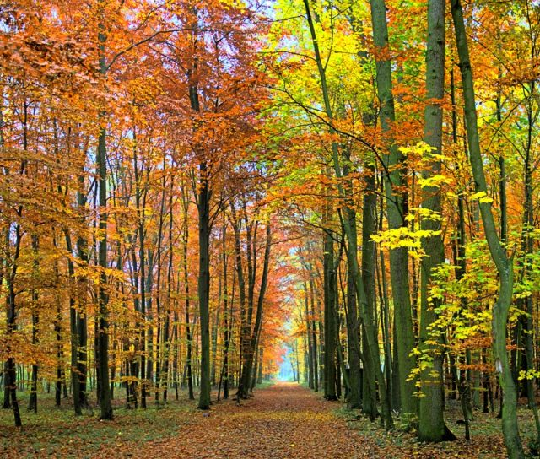
Source: http://www.wiki.lasypolskie.pl/_media/wiki/las_001.jpg

Resource B
Questions about the tree!

- Label any waste you can see on and around your tree. Don’t label human waste, only any natural waste. What happens to this waste over time?
- Where does this tree get its energy from? Does it waste any of this energy?
- Where does this tree get its food from?
- What happens to rain when it falls on this tree?
- Where does this tree get its water from?
- Can you see anything that is toxic or poisonous around your tree?
- What functions does this tree perform? Make a list of these.

Resource C
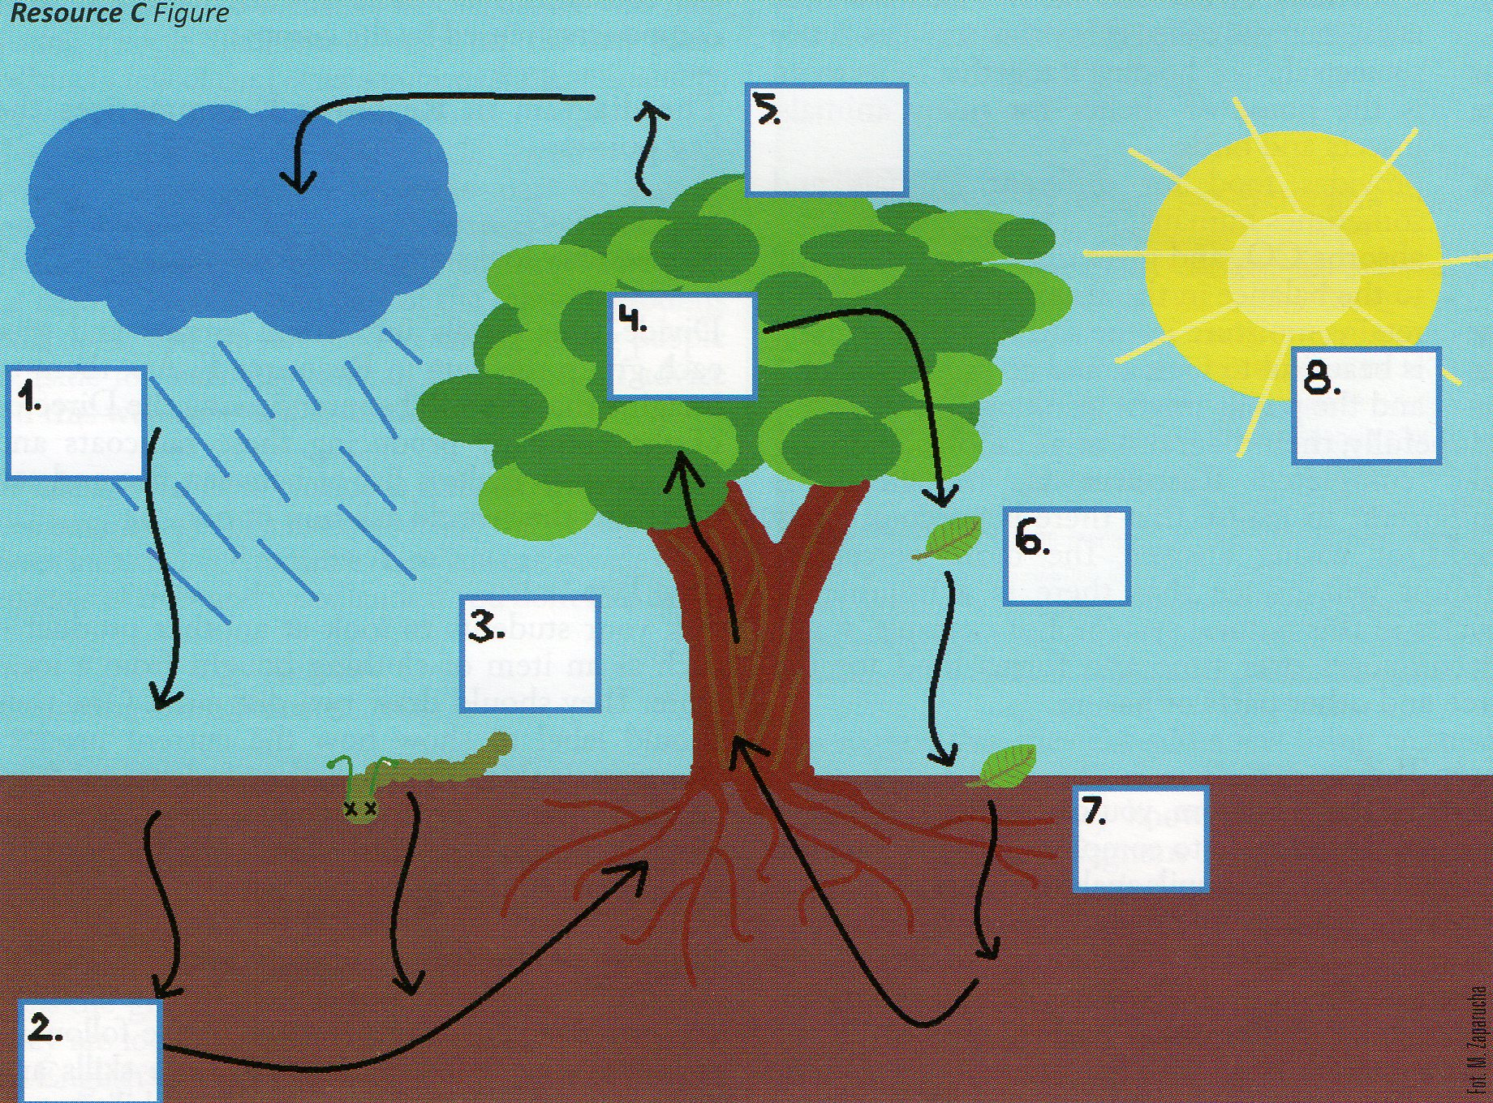
(Resource C by Marta Zaparucha)

Expressions to go into the boxes:
- animals die and provide food for the tree
- energy from the sun
- food enables leaves to grow
- leaves decompose and provide food for the tree
- leaves fall
- rain falls and soaks into the soil
- the tree gives off water which later forms clouds
- water used by the tree

The right answers!
1 f, 2h, 3a, 4c, 5g, 6e, 7d, 8b

Resource D

Human Systems and Nature compared.

Characteristics | Human System | Nature System
Waste | Lots and lots!
Energy used | From non-renewable sources like coal, gas and oil.
Toxicity | A lot of toxic materials used and produced through waste.
Water | Is polluted by the system.
CO₂ | Produces lots of CO₂ causing climate change.
Biodiversity | Is usually reduced, especially in farming.
Can you think of another one?

Suggested answers:
Waste
No waste at all or all what we think of as waste (such as dead leaves) is really food for other parts of nature.
Energy used
Only the suns energy is used. It feeds the plants that then give other food energy to animals
Toxicity
There are poisonous things but nothing that poisons other things unnecessarily.
Water
Water is not polluted by nature. It filters through the soil to rivers and goes back to air as clouds and is kept clean as it moves around the system.
CO₂
CO₂ is absorbed by vegetation and oxygen is given out. Everything is in balance and no extra CO₂ is produced.
Biodiversity
Natural systems grow in biodiversity until they reach what ecologists call a climax of vegetation.
Natural systems are generally strong and they recover from disasters over time.
Resource E

(Resource E by Marta Zaparucha)

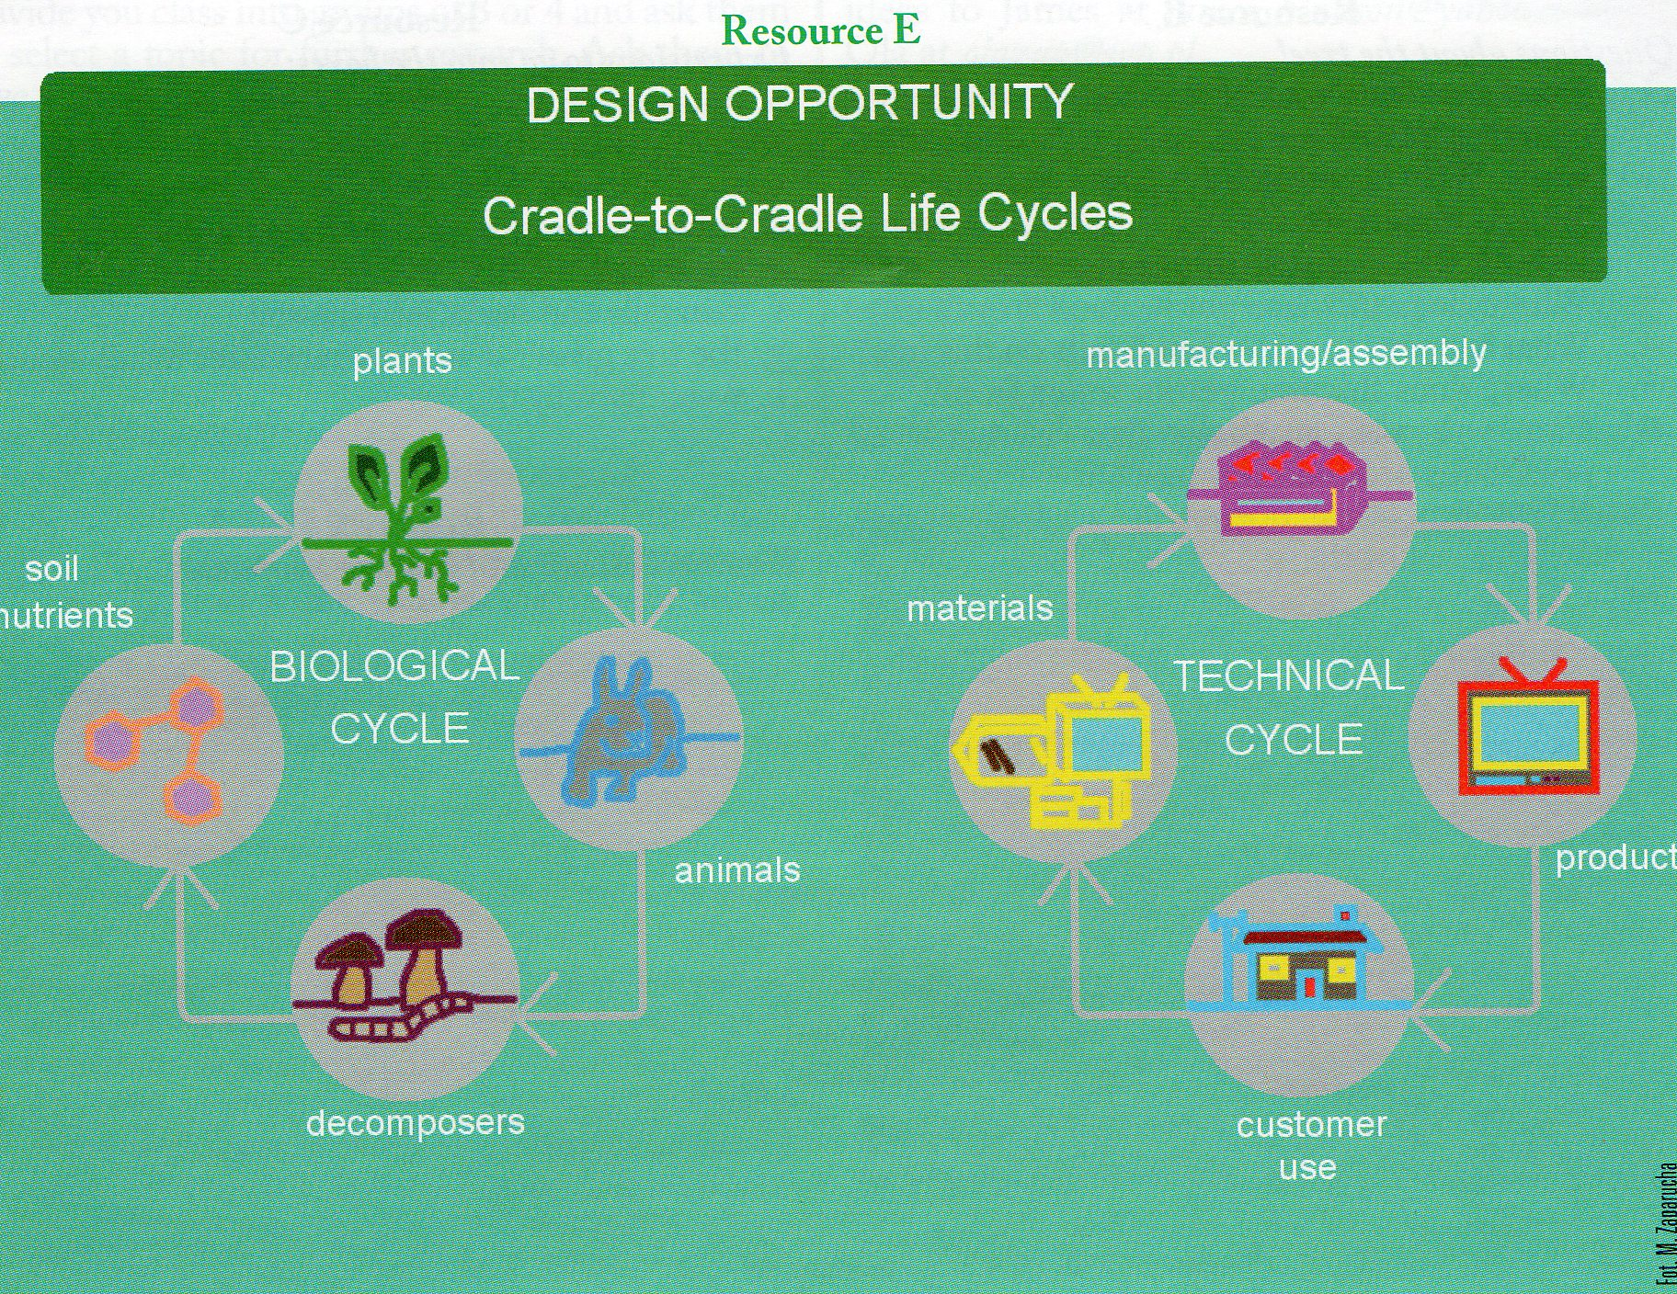

Resource F
Raincoats from Potatoes!

I was a potato.

I am a spud raincoat.

www.equilicua.com
I will be a potato again.

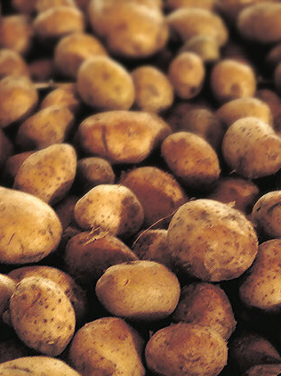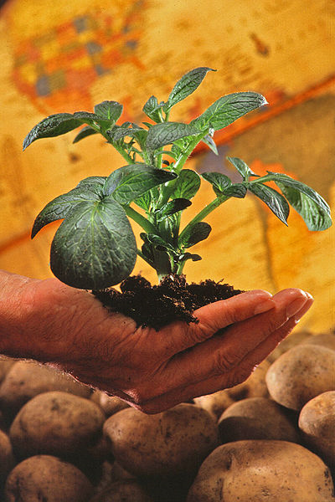

The Idea

This raincoat or waterproof cloak is made entirely of bioplastics derived from potato starch and other natural resources. The result is a 100% biodegradable and compostable product. This means that at the end of its life cycle it converts into organic matter and is returned in its entirety to the biosphere, closing the loop.

To reinforce this concept, the raincoat has a small clay ball with seeds integrated into it, developed by a Japanese microbiologist. This way the wearer can plant the raincoat when it’s no longer needed. The “spudcoat” doesn’t just return entirely to the natural cycle, it also helps the seeds inside grow into plants.

On the other hand, through the same product and its printed information, the raincoat also teaches consumers about this type of biodegradable plastic material, as well as its possible uses and the importance of knowing how to recognize and differentiate between others that are not. It also aims to demonstrate the importance of sustainable development.

The Product

Compostable:
- Can be disposed of as organic waste.

Provides sustainable alternatives:
- Promotes the use of new materials.
- Educates about climate change and oil dependence.

Biodiversity Conservation:
- Includes information about the importance of biodiversity.
- Includes seeds from native plants so that it can be “planted” instead of “thrown out.”

High durability:
- Only under specific conditions does biodegradation begin.

Help limit desertification!
Plant your spud raincoat!

Pictures:
Potatoes:
http://upload.wikimedia.org/wikipedia/commons/f/f3/Potatoes.jpg
Potato plant:
http://upload.wikimedia.org/wikipedia/commons/1/12/Potato_plant.jpg
The fantastic bioplastic:
http://www.equilicua.com/chubasquero_de_patata/Booklet_spudraincoat.pdf

