The article was first published by The Teacher (11/2009), the magazine for English teachers in Poland http://www.teacher.pl/

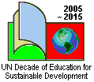

James Hindson
Aleksandra Zaparucha

Education for Sustainable Development in an English classroom

We’re trying to solve the problem – is it working?

The previous article highlighted the fact that planet earth is well and truly in a mess and that this has been caused largely by the hugely wasteful systems that we have developed over the last few hundred years to create and support a particular lifestyle that we consider “developed”.

Of course, humans are not completely stupid and there are a growing number of attempts by the global community to tackle the major environmental issues and to ensure that we can pass on a sustainable planet to future generations. These efforts include the world environment conferences of Rio de Janeiro in 1992 and Johannesburg in 2002 out of which came a number of agreements, such as the Convention on Biological Diversity to protect biodiversity and the Kyoto Protocol, and the forthcoming conference in Copenhagen to tackle the challenge of climate change. The European Union and national governments have also been active in developing legislation to enforce and encourage a reduction in the impact humans have over the planet, and business are working hard to develop new green products.

However, as the first article showed, these attempts, whilst producing a lot of good news and positive development, have largely failed. This chapter has two activities that will help you and your pupils to discover why!

Activity One
Consuming less stuff

Many people think that one solution to sustainability is to consume less stuff!

Step One
Divide the pupils into groups and ask each group to make a list of things that they “saved” recently – ways in which they have reduced, for example, energy use, water use, maybe travelled by bus and not by car and so on.

Step Two
Ask them to look at the advert in Resource A about saving energy and make a list of the reasons given for saving energy. If you have access to the internet in the classroom then you can find a lot of funny video clips on YouTube. For example, http://www.youtube.com/watch?v=E9-QzCuhnEw has a cartoon based advert by the UK’s Energy Saving Trust. If this is not possible, you can ask the students to watch this cartoon beforehand or as a follow up of this lesson unit.

Step Three
No doubt it is a good idea to save energy but is it fair and will it save enough to be useful? Ask the pupils to look at the newspaper articles in Resource B. On a copy of each article ask them to highlight the reasons the journalists give for the fact that saving energy at home will not really help stop climate change all that much!

Activity Two
Recycling – a good idea?

Another possible solution to sustainability that is often promoted to young people is recycling. This is a series of tasks for pupils based on ‘re-‘ words.

Step 1
Write the word ‘reuse’ on the board and elicit information from the students about its meaning. Explain what the prefix “re” means in front of a word.

Ask students to work individually, or in groups if their language level is lower and give them a few minutes to write as long a list as possible of words beginning with ‘re-‘. The list might include the following: redecorate, rethink, refurbish, restore, reread, redirect, return, restore, rewrite and so on.
After a couple of minutes ask students to compare their list with a partner or another group and to add to any of the new words to their list.

Ask each pair in turn to give you a ‘re-’ word they have thought of and write this on the board. Continue to go round the groups until all the words have been collected making sure words associated with education for sustainable development are included, i.e. refuse, repair, reduce, reuse, and recycle.

Step 2
Ask students to choose three words which they think will help to bring about sustainable development. No doubt they will think of ‘recycle’ but hopefully they will think of other words as well! If they cannot find three words then go though the list one by one asking the group what the word means and whether it could have anything to do with sustainability or not!

Try to end this step with the five common ‘re-’ words, i.e. refuse, repair, reduce, reuse, recycle, making sure that they are written in this order!

Step 3
Give each group of pupils a set of cards with the environmental ‘re-’ words written on them from Resource C. Ask the pairs or groups to put them in rank order starting with the action that is best for the environment, down to the action that is the worst.

You can then discuss why the pupils put them in the order they did. Refusing something is the best thing to do – not buying it in other words, followed by reducing or buying less stuff! The next step is to repair something when it goes wrong (rather than buying a new something!) followed by reusing it is some way when it cannot be repaired anyone more. The last step is to recycle it!

Many of your pupils might think that recycling products is the best thing to do once they have finished with them but it comes at the end of the ‘re-’ things to do. Even then recycling will not solve our environmental crisis.

Step 4
Give out copies of the statements on Resource D and ask your pupils to read each one and say whether they agree or disagree.

In essence none of the ‘re-’ words is the complete answer to all our problems, except maybe refusing to buy things, as they only delay the time when something becomes waste. Although we are very clever in thinking of ways of using recycled materials it is no answer to designing things properly in the first place!!

Activity Three
How about green products?

Many manufacturers these days try and get people to buy a particular brand of product because it is sold as being “green”. This is an activity based on advertisements for green products.

You can either use the advertisement below or choose adverts for other products or even ask the students to bring English advertisements in that they have found themselves. The adverts have to be about a product that is marketed as being green! You could enhance this activity by asking the pupils to bring in a product they have recently bought and also bringing products into the lesson for them to review.

Step One
As an introduction ask how many of the class have a mobile phone, how many have more than one, and how many they have owned over their life time. Then divide the class into groups and give them a copy of the advert in Resource E or bring real adverts and ask them why they are being encouraged to buy this product. Would they buy one?

The reasons will probably do with values, lifestyle and image and you can ask the pupils why they are being encouraged to “consume more stuff”. Even though they will have plenty of these items already, they are still told they need another one!

Step Two
Often we feel better if we buy “green stuff”. Ask the groups to have a look at advert in Resource F or bring real adverts for “green” products and then complete the table.

Things about the product which are “green” | Things about the product that are “not green”
If they find this difficult then you can give them some hints referring back to the “Take, Make and Dump” model. Ask them to think about
- the raw materials for this product – as well as general answers you might like to let the pupils know that mobile phones all have a small amount of a metal called coltan. This metal is found in Congo where wars are being fought to control the source.
- how the product is made.
- what happens to the product when it comes to the end of it’s life.

Then ask the group reflect on this statement: “This product is being sold to you as being “green”, but how green is it really?”

Each group should give a short presentation of their analysis of the advert. Question them if they think that they could be saying more!

Step Three
The main points to try and draw out are that whilst many green products are better than their non green alternatives, they are still not THAT good. For example, an item of clothing made of organic materials is maybe better than chemically based ones. But this again may not be any better if the ingredients have been shipped thousands of kilometres and made by cheap labour in China.

In a whole group discussion you can summarise the main issue which is “being less bad is not the same as being good” and then ask them to think of the meaning of this statement

Summary

These three activities demonstrate that consuming less, recycling and green products are not the complete answer to sustainability. Of course, there are lots of other solutions that are being promoted as well. We are trying to tackle global warming through both big actions at a global government and business level, e.g. things like capturing CO₂ from power stations and burying it in the ground, investing much more in renewable energy and encouraging new business practises to produce goods more efficiently. Actions are also being encouraged at a local and individual level encouraging people to consume less and consume the right things. These are all working to some extent but there are two catches. Firstly, they are not working quickly enough. Secondly, because the population of the planet is increasing and the relative proportion of people with better standards of living is also larger, any savings we make in the rich west are quickly cancelled out. You can see the problem. Obviously more radical solutions are needed. These are considered in the next article.

The authors would appreciate feedback on this and the following article as well as sharing good activities related to ESD. Mail your comments or ideas to James at <james_hindson@yahoo.co.uk> or Ola at <olazap@wp.pl>

For those interested in learning more on Education for Sustainable Development there is a training opportunity in the UK. For more details visit the Sense&Sustainability website at <http://www.senseandsustainabilitytraining.co.uk/> or mail at
<senseandsustainability@googlemail.com>

Resource A
Save Energy advert

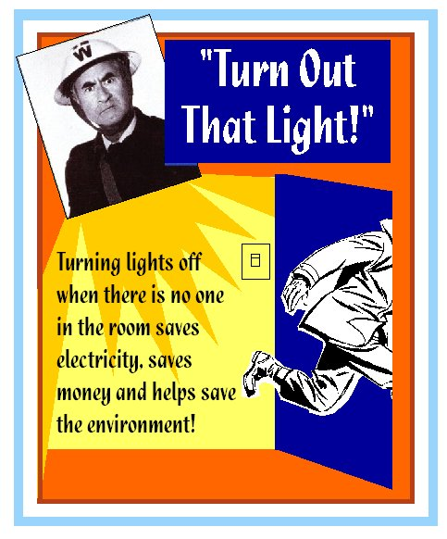

Resource B
Two articles

India and China use more energy

The population of India is growing and more people are getting richer every day. This is good news for people but bad news for the environment. Of course, it is good when people earn more money, but the result is that they are buying more things. Each day in China there are one thousand more cars on the road. China will also be building X more coal power stations next year as more people consume more energy. It is estimated that people in China will consume X times more energy by 2020 than they do now. No matter how much energy we save in Europe these savings will all be eaten up by China and India consuming more!

Why do we waste so much energy?

Our power stations in Western Europe are very inefficient. The best thing we can do to help stop climate change is to make our energy more efficiently. Most of our power stations waste more than half the energy during the process of making electricity. At least another quarter is lost when the electricity is transmitted through the wires. This means that at least three quarters of the energy is wasted before it gets to our homes. Why should we be asked to save energy at home when the electricity companies could save much more?

Resource C
Environmental ‘RE-’ Words

RE-use | RE-cycle | RE-duce
RE-pair | RE-fuse | RE-think

Resource D
Is recycling worth it?
Do you agree or disagree?

Statement | Agree or Disagree
1. We buy too many products that cannot be recycled.
2. A lot of things are sent to China for recycling.
3. Most things can only be recycled a certain number of times. Eventually they will become waste.
4. In Poland less than 25% of our waste is recycled.
5. We don’t care enough abut recycling.

