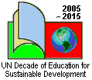

James Hindson and Aleksandra Zaparucha
Education for Sustainable Development in an English classroom

What a mess the world is in and how it got that way.

This is the second in a series of four articles that aim to support English language teachers using sustainable development as a context for teaching so as to achieve both language learning goals and an understanding of new approaches to sustainable development.

Is the world really in a mess?

Speaking/Listening activities

It might be difficult for young people to appreciate that the ecology or natural environment of the planet is in a mess. As they look around them they might feel that things are improving and indeed, in many parts of Poland, the environment is getting better on a local scale. The same is true of most other countries in Europe. The thing to emphasise, however, is that on a global scale there are huge challenges and the data and activities below illustrate the scale of the problem that we face.

- Describing/Discussing The Titanic Cartoon

Most young people will be familiar with the Titanic if only because of the film! You can ask them what they think the main message this cartoon delivers. They should talk about this first in groups and then as a whole class. There are sure to be different ideas but the key message is that the passengers on the Titanic thought that all was well and even when they hit the iceberg many did not worry very much as the ship was meant to be unsinkable! This is a metaphor for the planet today. Although we are heading for disaster (and we could add climate change as a label) people are still having a party either not realising the danger ahead or putting faith in technology to solve the problem or, worse still, just ignoring the warning signs!

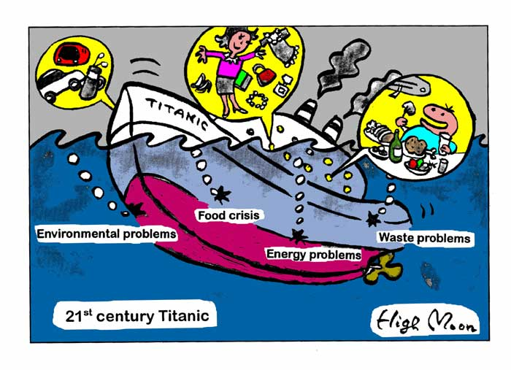
Author: High Moon

To help students you can write these questions on the board or distribute them on separate pieces of paper:
- Why did people think the Titanic was unsinkable?
- What happened on her maiden voyage across the Atlantic?
- What were the passengers doing when the ship was sinking?
- How does this resemble the situation of the Earth?
- What are the ‘holes’ in the Earth’s Titanic?
- Can you add any more ‘holes’ to the Earth’s Titanic?
- What are people doing while the globe is sinking?
- What is going to happen if nothing is done immediately?

With students whose English is not so good, you can hold a class discussion giving the questions one by one to make the task easier.

  - Reading Graphs, Maps and Statistics

Again, the young people should work in groups and you should ask them “what is the main message of this data?” You can either show the data to the whole class or give each group just one piece of data to look at and ask them to write a short title for each graph. When taken together, the messages of the graphs, maps and statistics are depressing. Each of the key things related to human survival, energy, food and water, are reaching their limits and when linked with an increase in the population of the planet means that “tipping points” will soon be reached. A tipping point is a point of no return.

The main messages of the graphs, the map and the statistics are the following:

Figure 1 and 2 – the planet is running out of the main source of energy – oil.
Figure 3 – the average temperature of the planet is increasing and reaching a danger point.
Figure 4 – forest land and biodiversity of the planet are decreasing quickly. This means that it will be more difficult for the planet to feed itself.
Figure 5 – water supply is getting more insecure,
Table 1 – on the global scale the ecological footprint is well over the planet resources,
Table 2 – the population of the planet is on a constant increase adding to the problem.

Again, to make things easier, you may give students lists of questions for each graph, map or table with statistics.

Figures 1 and 2
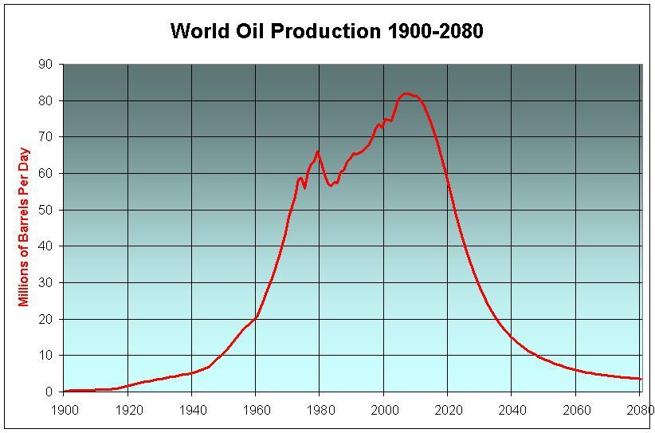
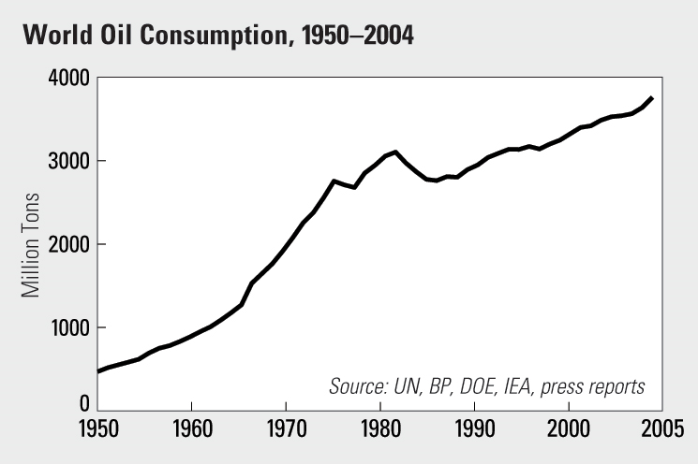
Source: http://www.worldwatch.org/node/1811 Source: http://www.paulchefurka.ca/Population.html

Questions
- What is given in millions of barrels or tons in the graphs?
- What time span do the graphs show?
- When did the use of this resource start?
- Which countries produce most of this resource? Which use most of it?
- What do we use it for?
- What is going to happen by 2080?
- What do you think will happen after that?

Figure 3
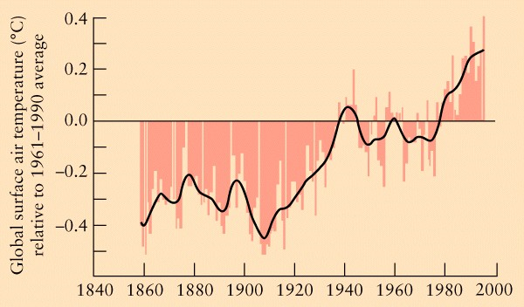

Source: http://www.thankyouocean.org/threats/climate-change

Questions
- What was the general tendency of the world’s temperature between 1880 and 2000?
- What do you think the predictions for future temperature are?
- What might be the cause of this situation?
- What can be done on a global scale to prevent further temperature rise?
- What can individual people do?

Figure 4

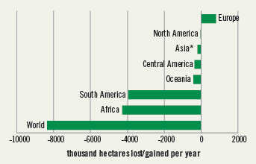

Source: http://earthtrends.wri.org/updates/node/303

Questions
- Which part of the world loses most forest each year?
- Which part of the world is gaining in forest land?
- What is the total amount of forest land lost each year?
- What do you think the reasons for this forest loss are?
- What are the effects of the loss of forest both locally and globally?
- Is Poland losing or gaining forested area? Why?

Figure 5

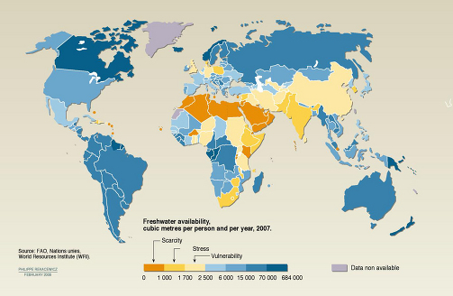

Source: http://www.climate.org/topics/water.html

Questions
- What area does the map present?
- What do colours indicate?
- Which regions have the worst situation?
- Which regions do not feel this pressure?
- Which group does Poland belong to? Is this surprising?
- Give the title to the map.

Table 1

Country | Ecological  footprint (ha)
India  Kenya  China  Brazil  Russian Federation  Poland  Germany  UK  Czech Republic  USA | 0.9  1.1  2.1  2.4  3.7  4.0  4.2  5.3  5.4  9.4
The world average | 2.7
World resources available | 2.1
Source: http://en.wikipedia.org/wiki/File:Human_welfare_and_ecological_footprint.jpg

Questions:

- What do you think an ecological footprint is and why is it given in hectares?
- How does this information show we are living in an unsustainable way on the planet?
- If everyone had the same footprint as people in the United States of America, how many planets would we need to support our lifestyles?
- Are people in Poland living sustainably or unsustainably?
- Do you think the ecological footprint of Poland has grown in the last 20 years? Why/Why not?

Table 2
World historical and predicted populations in millions and by percentage distribution

Region |  | 1750 | 1800 | 1850 | 1900 | 1950 | 2000 | 2008 | 2050 | 2150
World | m | 791 | 978 | 1,262 | 1,650 | 2,521 | 5,978 | 6,707 | 8,909 | 9,746
World | % | 100 | 100 | 100 | 100 | 100 | 100 | 100 | 100 | 100
Asia (%) |  | 63.5 | 64.9 | 64.1 | 57.4 | 55.6 | 60.8 | 60.4 | 59.1 | 57.1
Europe (%) |  | 20.6 | 20.8 | 21.9 | 24.7 | 21.7 | 12.2 | 10.9 | 7.0 | 5.3
Africa (%) |  | 13.4 | 10.9 | 8.8 | 8.1 | 8.8 | 12.8 | 14.5 | 19.8 | 23.7
South America (%) |  | 2.0 | 2.5 | 3.0 | 4.5 | 6.6 | 8.5 | 8.6 | 9.1 | 9.4
North America (%) |  | 0.3 | 0.7 | 2.1 | 5.0 | 6.8 | 5.1 | 5.0 | 4.4 | 4.1
Oceania (%) |  | 0.3 | 0.2 | 0.2 | 0.4 | 0.5 | 0.5 | 0.5 | 0.5 | 0.5
Source: http://en.wikipedia.org/wiki/World_population

Questions
- What is given in millions?
- What time span does the table show?
- What different regions does the table consider?
- What is the total change in population between 1750 and 2150? What implications will it have?
- How does the proportion taken by European population change? What was it in 1750? What had changed by 1950? What is expected by 2050?
- How does the proportion taken by African population change? What was it in 1750? What had changed by 1950? What is expected by 2050?

The statistics in Table 1 show the ecological footprints of different countries and global averages. An ecological footprint is a measure of how much land area a lifestyle requires to supply the resources that lifestyle consumes and the area of land needed to absorb the waste that lifestyle produces. The fact that the average footprint of 2.7 hectares is larger than the theoretical average of 2.1 ha shows immediately how unsustainably we are living. The figures also show how seriously unsustainable our consumption is, and how some countries are consuming more than their fair share. The pupils don’t need to know how an ecological footprint is calculated to do the activity. They just have to know that it is a measure of our impact on the earth

Basically the data shows that we are consuming more resources than the planet has available and that some countries consume much more than their fare share. If the pupils ask how this is possible you could compare the ecological footprint with money in the bank. If you have a lot of money invested then you live off the interest – you don’t touch the capital. Currently we are eating into our ecological capital with the previous activity showing that it has nearly all gone!

Now ask the students to consider the data in Table 2. As they can observe, the world population is growing constantly but the resources available do not increase. What implications for the ecological footprint in the future does it have?

Why is the world in this mess and how did it get this way?

Speaking/Listening activities

Explaining how we have got ourselves into this unsustainable mess is complicated because there are lots of interrelated reasons. Although many people, especially politicians, like to blame individuals for the problems our consumption is not really at the heart of the problem. It is the way things are made. The activity below is designed to illustrate what is called a “Take – Make – Waste” system of production. Basically we are a hugely wasteful society in terms of energy and raw materials. We are wasteful for a large number of reasons but mainly because we don’t pay the full cost of all the pollution and waste that we cause. You might end up having some interesting discussions with your students!

Diagrams

Ask you students to look at the chair they are sitting on and to think about how this chair was made. Ask them to draw a simple diagram, in English of course, showing the story of the chair from the moment the raw materials were dug from the ground (or tree chopped down if they are wooden) to the moment when the chair is disposed of.

Don’t give them too long and say that you are not expecting too much detail.

Review their first efforts and make some comments on them. It is likely that most of the diagrams will just have a simple industrial process on them, in which case you can prompt them to think about the thing they have forgotten about, such as pollution and waste. Ask them to add these things to the diagram.

When they have done this you can compare their diagrams with the one below and stress that really all our processes of making everything (including food, clothes and electronic goods and so on) is incredibly wasteful. They produce more waste than things! THIS is why the world is so unsustainable – we have invented really wasteful ways of making things.

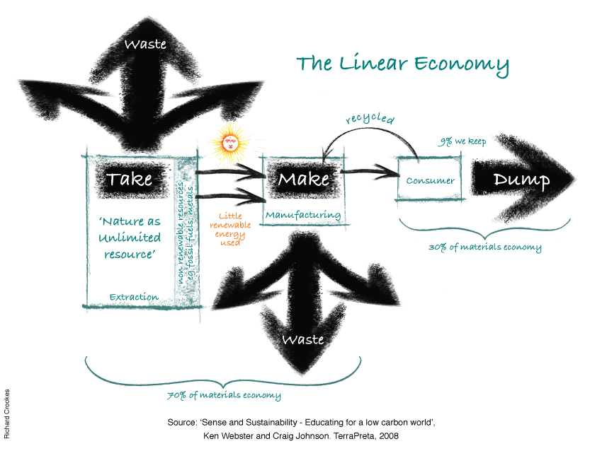
Conclusion
These activities lead to fairly depressing conclusions! It is worth encouraging the pupils that there are answers – and that we shall look at these in the next lessons!

Follow up activities
Divide the class into three groups. Each is going to look at one of the websites given below.

- Access the footprint website at
http://www.ecologyfund.com/ecology/res_bestfoot.html to learn how it is calculated. Present it in a simple way.
- Access the website with the footprints of other countries at http://en.wikipedia.org/wiki/List_of_countries_by_ecological_footprint. Find a few which have the same/higher/lower footprint as/than Poland.
- Access the website of the story of stuff at www.thestoryofstuff.com and summarise it.

During the next lesson, put the students in the same groups to re-tell what they have learnt from the websites. Next, reshuffle them into groups of three in the way that each member of the group has become an expert in a different thing. Ask the students to report to their partners what they have learnt from the websites.

The authors would appreciate feedback on this and the following articles as well as sharing good activities related to ESD.

Training opportunity
For those who want to explore ideas of ESD and English language teaching further, James Hindson and Aleksandra Zaparucha have prepared:
Intensive English Language courses in the UK
Content and Language Integrated Learning
and Education for Sustainability: 13th-19th June 2010
Education for Sustainability
for English Language Teachers: 20th-26th June 2010

VENUE: the historic market town of Shrewsbury, the birthplace of Charles Darwin.
CONTENTS: lectures, discussions, visits to schools and meetings with teachers.
FUNDING: courses eligible for the EU Comenius Grundtvig funding (deadline for applications: the middle of January 2010).
BOOKING: http://www.senseandsustainabilitytraining.co.uk/

If you wish to get more details on the courses and/or booking, email us at: senseandsustainability@googlemail.com
You can also email the leaders at: james_hindson@yahoo.co.uk or olazap@wp.pl

