Teaching Geography through projects: a European and linguistic dimension
Aleksandra Zaparucha
School Complex number 10,
pl. św. Katarzyny 9, 87 – 100 Trouń, Poland
olazap@wp.pl

Abstract
This article briefly presents the position of project teaching in both English and Geography. On that basis the author concludes this is the method which best suits the objectives of bilingual Geography teaching. The following description of a project undertaken with bilingual classes on the 2nd anniversary of the Poland’s membership of the European Union shows advantages both in terms of content and language of the method employed.

Key words
bilingual teaching, CLIL, EFL/ESL, projects, language skills integration, EU

Introduction
Teaching through projects has numerous advocates, both among English and Geography teachers. Every modern English coursebook for school students contains suggestions for project topics to be prepared in the form of posters. For instance, Snapshot elementary (Abbs, Freebairn and Barker 1998) suggests using a Snapshot of where I live or Snapshot of a famous place. The goals of such a project are to increase the motivation and engagement of the learners, as well as practice writing. Other projects integrate all the language skills (integrated-skills approach in teaching English as a Foreign/Second Language (EFL/ESL)) and may easily be used by Geography teachers, such as Street interview on a specific topic or String and pin display: tourist destinations within a town (Fried-Booth, 1997).

For geographers the project method is a great way to give up the textbook as the main source of information. For Geography students it is also an opportunity to try something different, especially if the project is well prepared, both methodologically and practically. Projects in geography may range from short Geography-only projects to events of a few-days’ duration integrating Geography with other disciplines (Bailey, 1991; Gołębniak, 2002). No matter what the organisation aspect of Geography project work is, it enables the students to ‘put their hands on’ a given topic.
Taking all the above into consideration, projects for bilingual Geography teaching seem an ideal solution. Project work, as a part of Content and Language Integrated Learning (CLIL) advocated by the EU (also referred to as Content-based Instruction (CBI) within Communicative Language Teaching (CLT), allows the learners to observe that a foreign language is a necessary tool for solving real problems and undertaking real tasks. Thus, the motivation, independence and confidence of learners grow. Moreover, the project method for both, language and content-teaching, gives the very teacher a chance to observe the students in various learning situations and thus to evaluate their abilities, skills and needs.

A bilingual English-Geography project on European Union
The project was undertaken by four bilingual classes of both lower level (13-15 yrs) and higher (16-18 yrs) level of the School Complex number 10 in Toruń. It was connected with the second anniversary of Poland’s membership of the European Union. The stages of preparation, realisation and evaluation of the project (Figure 1) were based on the Field Studies Council publication for GCSE students Projects without panic! (Field Studies Council, 1989).
1. Choosing a project idea:
The 2nd anniversary of Poland’s membership of the EU – a street survey

2. Stating a problem, hypothesis or investigation:
opinion of citizens of Toruń on Polish membership of the EU

3. Planning the fieldwork:
preparing a questionnaire for the street survey
Feedback

4. Doing the fieldwork and recording it:
carrying out the street survey and recording the results;
interviewing three family members

5. Presenting the result:
graphic presentation of the findings in the form of a written report

6. Explaining the results:
discussing the results of the street survey
discussing the results of the family survey
presenting the students’ own opinion on the topic

7. Conclusions:
finding explanation of the project results

Figure 1. Stages of the project on the 2nd anniversary of Poland’s membership of the EU

Choosing a project idea. The fact that the project work was done in spring went some way to suggesting the topic of this project. Poland joined the EU on 1st May 2004, and that was the time to sum up the outcomes of its membership. This issue was widely discussed in the mass media; the stress was put both on the economic advantages here in Poland and on the mass emigration of young Poles in search of better economic conditions. Last but not least, EU issues are an integral part of the National Curriculum for Geography teaching at all school levels.
Stating a problem, hypothesis or investigation. The discussion regarding the support of Toruń’s population for Poland’s membership of the EU was conducted in the classroom. The students tried to predict the level of support for the EU, as well as the percentage of the population that would like to emigrate.
Planning the fieldwork. As the project was to include 4 classes and in order to save the lesson time, the decision on what to include into the questionnaire and how to construct it was made by the teacher. The outcome is presented in Figure 2.
Questions | Respondents
Questions | 1. | 2. | 3. | 4. | 5. | 6. | 7. | 8. | 9. | 10.
1. When did Poland join the EU? (I know/I don’t know)
2. Are you satisfied with this fact? (yes/no/?)
3. What is the greatest advantage for Poland of EU membership?
4. What is the greatest disadvantage for Poland of EU membership?

5. Can you name two countries which have opened their labour markets to Poles? (yes /no)
6. Have you ever worked abroad and what are your plans? (a. yes and I want to do so again; b. yes but I don’t want to do so again; c. no but I want to; d. no and I don’t want to)

Figure 2: A questionnaire for the street survey on Poland’s membership of the EU

Doing the fieldwork and recording it. All bilingual classes have some lessons taught in groups of 15-18 students, so it is possible for them to be taken to the city centre accompanied by one teacher. As the school is located close to the city centre, there were no problems in carrying out the survey during one 45-minute Geography lesson with each group. Students worked in pairs and each pair was to question 10 randomly selected people (see Figures 3 and 4). Before the survey the students were instructed on how to introduce themselves, ask for permission to conduct the survey and finally how to ask the questions and record the answers. The instruction was given in English, but the survey itself was conducted in Polish.

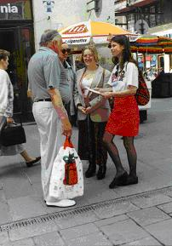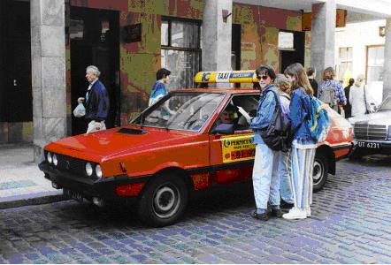
Figure 3 and Figure 4: School students carrying the street survey
Figure 5 presents the introduction from one of the student’s survey reports with the questions and all the general information included.
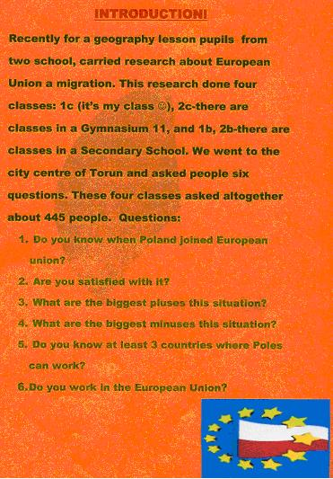
Figure 5: Introducing the project

Presenting the results
After all the groups had completed the task, the teacher summed up the findings. Altogether, the students interviewed 445 people of various ages.
To avoid a situation in which all the students would present literally the same results of the survey in writing, they were also asked to interview three members of their families of different ages, as well as to include their own opinion on the topic (especially questions 3, 4 and 6). The results were presented in the form of individual projects (John and Richardson, 1990). Earlier, however, the students were given a model of a project, i.e. what the front page should include, what the introduction should inform the reader about, how to calculate the results into percentages and how to present them in graphic form. Finally, the students were told how to sum up the project by quoting their family members and giving their own opinions.
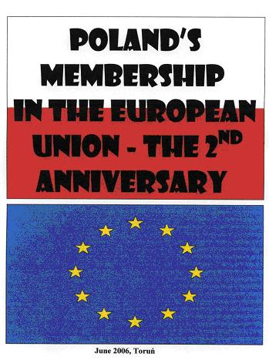
The following figures present examples of the report covers (Figures 6 and 7) and the variety of the methods employed by the students to present the statistical data (Figures 8 – 13).
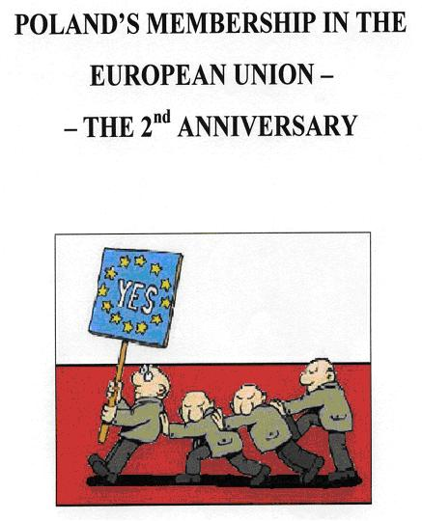

Figure 6 and Figure 7. Two examples of the covers of student’s reports on the street survey.
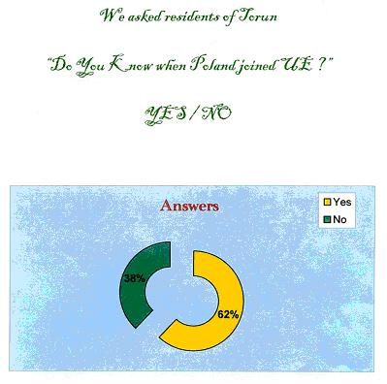
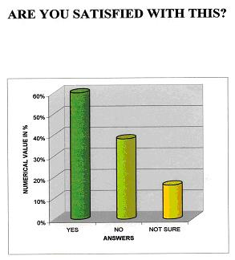

Figure 8. The street survey results – question 1 Figure 9. The street survey results – question 2

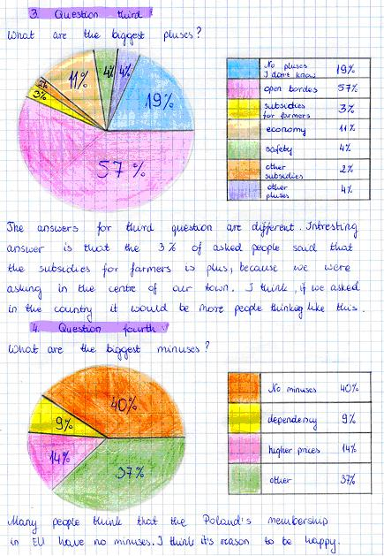
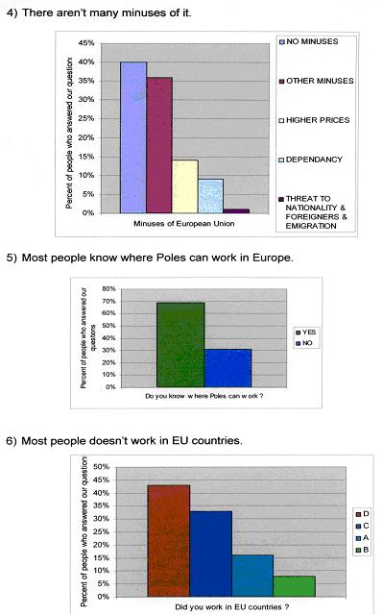

Figure 10. The street survey results – questions 3 & 4 Figure 11. The street survey results – questions 4, 5 and 6

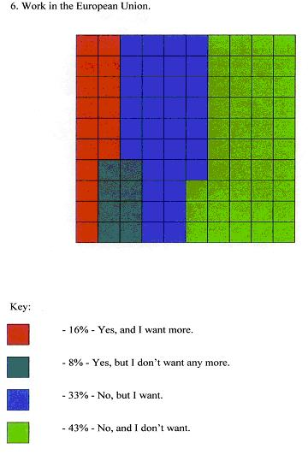
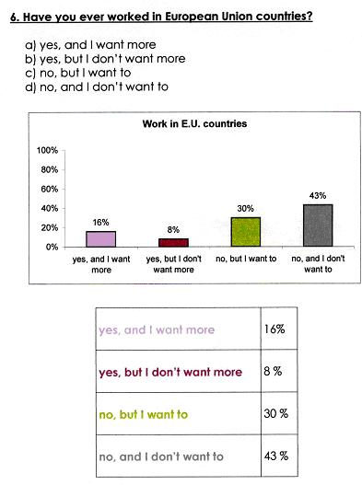

Figure 12. The street survey results – question 6 Figure 13. The street survey results – question 6

Explaining the results. As an explanation of the findings of the survey, the students commented on each question, often giving interesting and intelligent comments. Interestingly, there was frequently a discrepancy in students’ interpretation: e.g. the fact that 62% of the respondents knew the date of Poland’s joining the EU was for some a positive result, while others thought is was much too low for such an important event just two years on. Most of the students were surprised that ‘only’ 49% of the people questioned opted for emigrating (a+c answers for question 6); they expected much a higher result. Additionally, they presented the opinions of their family members as well as their own.
Conclusions
In the final part of their written project, the students tried to give solutions to the situation, for example those who thought more people should know more about the EU opted for more educational activities (TV programmes, school curricula).
Figures 14 – 21 present some sample pages from the students’ reports with their comments.

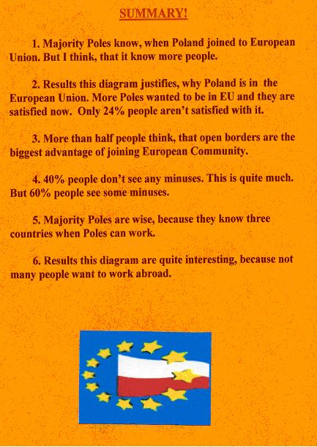
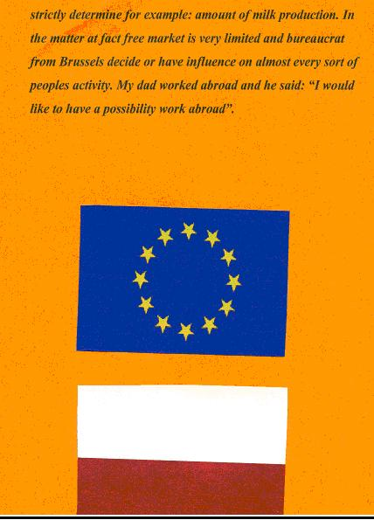
Figures 14, 15 and 16. An example of the summary, a student’s opinion and the student’s family’s opinion presented in the project report
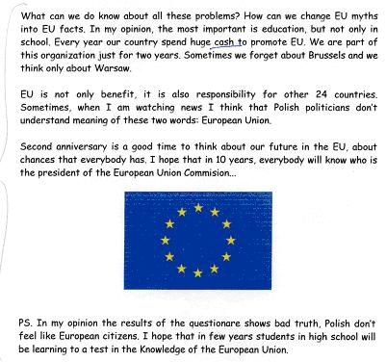
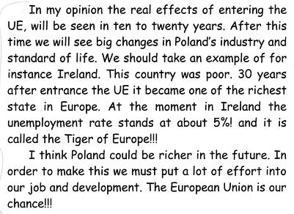
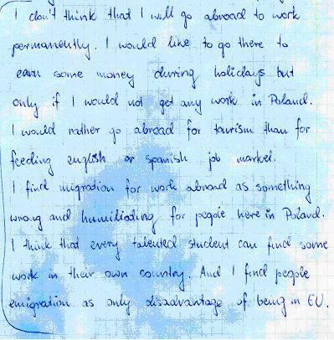
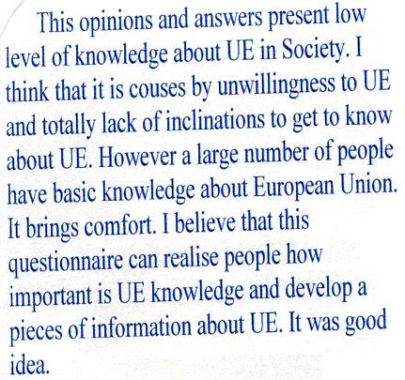

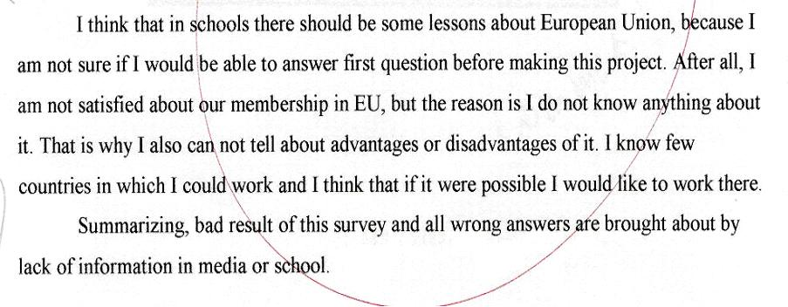
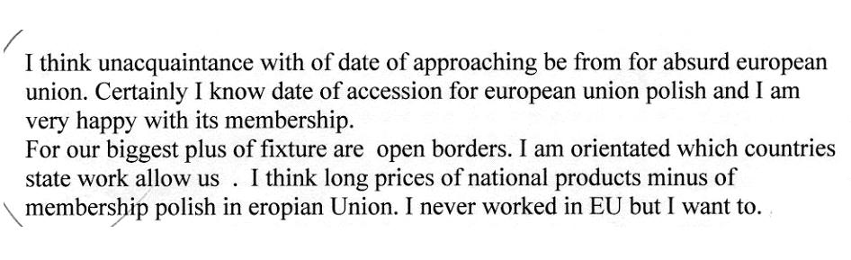
Figures 17 – 21. Examples of students’ comments on the project
Figure 22. An example of a student’s summary of the project – language problems

Feedback
The basis for the project evaluation was on the feedback received and digested both during and after completing the project. It is the basis for any corrections and changes in the project stages, especially if it was to be repeated with the next groups of students. In the case of this project, the analysis of the results revealed some important information about the respondents was missing: namely their age and sex. To gain such information it would be enough just to note down the observation results, i.e. male/female and student/working/retired.
Another difficulty was connected with the analysis of the answers to questions 3 and 4. As they are open questions, it was extremely difficult sometimes to decide on categories. For instance, 57% of all the answers to the question on the advantages of Poland’s membership in the EU mentioned open borders; however, the respondents stressed various aspects of free movement, such as education, work and tourism.
Summing up, if the survey was to be repeated in future years, the questionnaire itself should be corrected (age, sex, suggested answers to questions 3 and 4). This might enable the students to monitor the changes in the opinions on EU membership.

Conclusion
The presented project on Poland’s membership in the European Union was not time-consuming. Two 45-minute lessons were enough to complete it, though; the goals of both an English and Geography teacher can be achieved. According to the Content and Language Integrated Learning objectives, a well-designed bilingual lesson should have the following four elements: content, communication, cognition and culture. In our case these were the following aspects:
CONTENT:
  - developing research skills;
  - collecting geographical data in the form of the street survey;
  - transforming and presenting geographical data in the form of a project;
  - developing geographical knowledge on Poland’s membership in the EU;
  - developing geographical knowledge on people’s opinions on EU membership;
  - using a word processor for presenting statistical data;
COMMUNICATION
  - using the language for a real-life task;
  - using the language to communicate with the teacher and peers;
  - using the language to write the report;
COGNITION
  - learning to think by combining abstract and concrete concepts with language acquisition;
CULTURE
  - developing social skills at school (group-work);
  - developing social skills during communication in an out-of-school situation;
  - being exposed to other people’s opinions;
  - developing awareness of otherness and self.
Nearly all students presented language that was understandable. In spite of the mistakes, be it spelling, grammar or vocabulary, the texts were communicative to a teacher of the same mother tongue. There were some projects, however, in which the meaning of the language employed was hard to decipher (Figure 22). Generally, this so-called inter-language, which is a kind of language the learners create for their needs before they master the target language, is an important issue in EFL/ESL teaching. In the case of project work in bilingual teaching, however, the most important thing is to make the students use the language in an every-day situation, and not the correctness of the language.
As teaching Geography bilingually in the form of a project stands out from normal classroom-type classes of both Geography and English, 65 students from 2 classes who took part in the survey in the streets of Toruń had a chance to give their opinions on that form of lesson. As many as 62% of them said it was good or very good, while 18% did not like the project. Although it was the teacher who takes the final decision on the form and structure of the lesson, the students’ opinions should also be taken into consideration. Their positive attitude would be a key element to successful project teaching.

Bibliography to project teaching

ABBS B., FREEBAIRN I., BARKER C., 1998, Snapshot Elementary, Student’s book, Longman, Pearson Education Limited, Harlow.
BAILEY P., 1991, Zajęcia terenowe w Lubiczu Górnym, Geografia w Szkole, nr 4.
DOBOSIK B., KARDAS K., MODZELEWSKA B., 2004, Przestrzeń geograficzna, w której żyje człowiek, SOP, Toruń.
FIELD STUDIES COUNCIL, 1989, Projects without panic!, A practical do-it-yourself GCSE, Field Studies Council, Preston Montford.
FRIED-BOOTH D., 1997, Project Work, Resource Books for Teachers, Oxford University Press, Oxford.
GEOGRAPHY THROUGH TOPICS IN PRIMARY AND MIDDLE SCHOOL, 1989, the Geographical Association, Sheffield.
GOŁĘBNIAK B. D. (Ed.), 2002, Uczenie metodą projektów, WSiP SA, Warszawa.
JOHN P. R., RICHARDSON D. A., 1990, Methods of Statistical Analysis of Fieldwork Data, the Geographical Association, Sheffield.
KRYNICKA-TARNACKA T., WNUK G., WOJTKOWICZ Z., 2004, Moje miejsce w Europie, SOP, Toruń

