


The Ministry of Education and Science
Shumen University Konstantin Preslavski
In-service Teacher Training Department - Varna

Summer Course - Varna '2004
“Fact IV”
Forum for across the Curriculum Teaching Group
Science across the World

Networking and Training for Content and Language
Integrated Learning
(05.07 - 09.07.2004)

CREATE CULTURE THROUGH SCIENCE
WATER

Course Content

Albena Nikolova
- Water in Bulgarian Literature – Creative Writing

Lyubov Dombeva
- Water experiments
- Beliefs about Water – Developing Listening Skills in EL

Maria Koeva
- WaterDoc Comes to Help

Stefka Kitanova
- SAW
- FACT – Content Process and Product of the Project
- Water experiments continued

Valentina Angelova – Course Director
- Developing Language Skills while Focusing on Science,
Literature and Culture (Water Variations)
- The Cross-curricular Approach in Teaching English as a FL
‘ Testing’ Water

THE TEAM

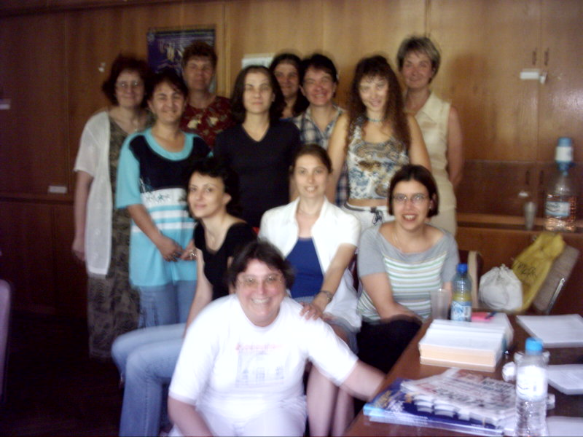
Iva – the Ice cream
Valya – the Vitamin
Krassimira – the Key
Elvira – the Experience
Julia – the Jacket
Stefka – the Snake
Lyubov – the Lotus
Albena – the Albatross
Merry Maria
Emilia – the Eagle
Detelina – the Dog
Tsveti – the Tulip
Svetlana – the Sun
Course Participants
Детелина Йорданова Маринова – англ. ез
Гр. Велико Търново 5000, ул. “Камен Зидаров” 14
Detelina@vali.bg

Елвира Дамянова – англ. ез., руски ез.
Гр. Свищов, ул. “Средна Гора” 1
Вх. Г, ап. 15
D_blagoev@thezonebg.com

Емилия Христова Дишева - математика
Гр. Велико Търново, 5000, ул. “Краков” 5
Вх. В, ап. 4, ет. 2
Emilydisheva@abv.bg

Ива Симеонова Рангелова – англ. ез.
Гр. Севлиево, 5400, ж.к. “Димитър Благоев”
Бл. 3, ап. 2, вх. Г, ет.1
Evgeni_68@abv.bg

Красимира Кирчева Крумова – англ. ез.
Гр. Свищов, 5250, ул. “П. Евтимий” 72
Бл. 2, вх. Б, ап. 12, ет. 4
Krrass@abv.bg

Светлана Пламенова Стойчева – български ез, история, англ. ез.
Гр. Тутракан, обл. Силистра, бл. “Росица”2
Ет. 4, ап. 10
Jovkov@mail.orbitel.bg

Цвета Александрова Кръстева – изобразително изкуство
и история на изкуството
Гр. Велико Търново 5000, ул. “Оборище” 8
Вх. Г, ап. 21
Тел. 0889 274 783
www.cveta.net
cveta_26@yahoo.com
mail@cveta.net

Юлия Петрова Йозова – англ. ез.
Гр. Свищов, 5250, ул. “П. Ангелов” 15
Бл. 1, вх. Г, ет. 5
Тел. 0631 42246, 0888 777 366
D_blagoev@thezonebg.com

Tutors
Albena Nikolova – albenahris@yahoo.com

Lyubov Dombeva – dombeva@abv.bg

Maria Koeva - maria_koeva@yahoo.com

eng. Stanislav Shterev – stan_sterev@abv.bg – 9010 Varna, ITTD

Stefka Kitanova - skitanova@scienceacross.org , butsa13@hotmail.com

Valentina Angelova – 9010 Varna, ITTD, valka55@hotmail.com

Group poems

WATER

It looks like crystal
It sounds like waterfall
It smells like perfume
It provokes me to dream
(Svetlana)

It looks like waves
It sounds like roaring sea
It smells like seaweeds
It provokes you to swim
(Iva – the Ice cream)

It looks like the rising tide
It sounds like the splashing mermaids
It smells like the cool breeze
It provokes myths and legends
(Lyubov)

It looks like a mirror
It sounds like music
It smells like a rose
It provokes my spirit
(Julia)

It looks like transparent air
It sounds like birds singing
It smells like perfume after rain
It provokes swimming
(Albena)

It looks like a blue transparent sky
It sounds like a beating chord in love
It smells like the hair of a baby
It provokes like the smile of a beautiful woman
(Tsveta)

It looks like silver
It sounds like music
It smells like spring
It provokes you to dream (= to live)
(Elvira)

It looks like nylon curtains
It sounds differently –
as a lullaby song and as a thunder storm
It smells like sea ☺
It provokes you to desire it
(Emily)

It looks like air
It sounds like waves
It smells like sea
It provokes drinking
(Merry Maria)

It looks like winter
It sounds like spring
It smells like autumn
It feels like summer
It provokes changes
(Stefka – the Snake)

HAIKU POEMS

Rainbow is colourful
Colours are joy
Joy is peace
(Iva – the Ice cream)

Dewdrops
Silver dewdrops, golden rays
Dancing stars in moonlit pit
Distant sound of ringing bells
For the one who wants to hear it
(Detelina)

Water is a symbol of life
People are a symbol of life
So, People are a symbol of water
(Elvira, Emily, Merry Maria)

If waterless – I die,
If waterfull – I exist,
I choose – to live!
(Elvira, Emily, Merry Maria)

My water
Your water
Water for you and me
(Julia)

If a drop of water is love
And the river is life
I am an Ocean
(Krassi – the Key)

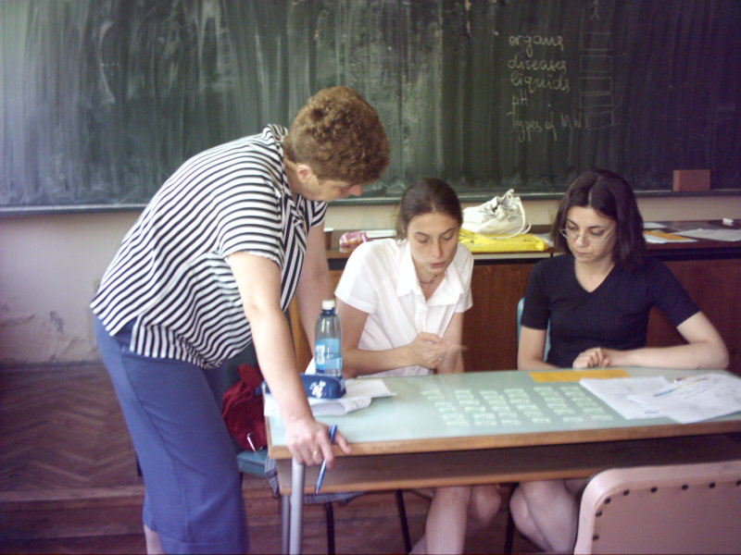

I saw the rainbow
It was from five colours
The colours of rainbow
(Svetlana)

Water is life
Ice is death
Vapour is in between
(Stefka – the Snake)

Water dripping off my hair
Makes me remember your smile
(Lyubov)

Waterfall in front
Water denying stillness
Breaking the silence
(Albena)

Rivers flow like golden paths,
Cascade down the mountainside
Chasing peace.
Deserts, stagnant seas of light,
Never get that kiss of life.

Water is pleasure in hot summer night
It is an enigma, a secret
And a kind of life’s fight.
(Krassi – the Key, Iva – the Ice cream, Emilia – the Eagle,
Lyubov – the Lotos, Stefka – the Snake)

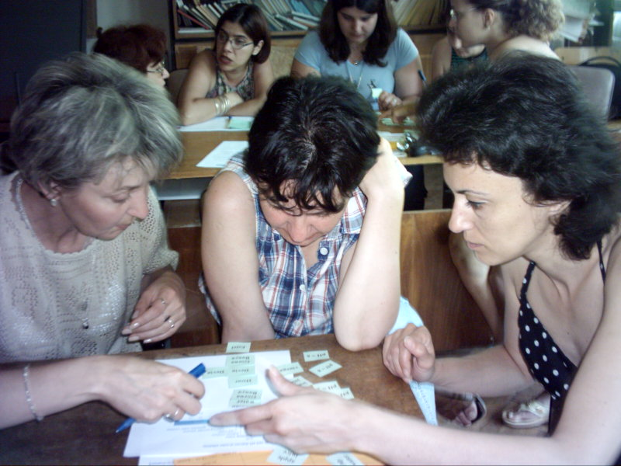

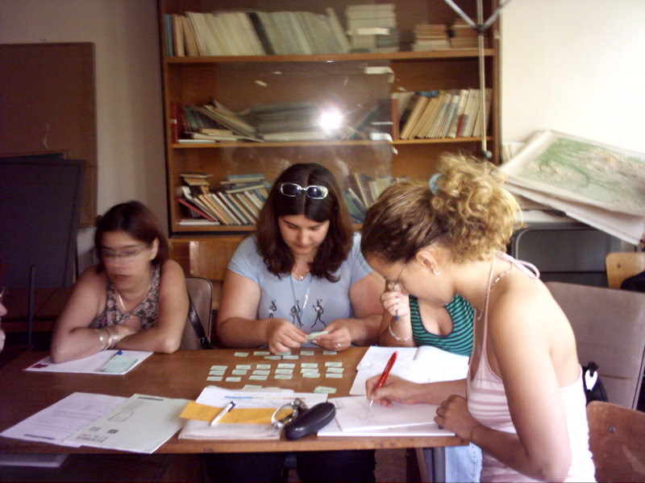

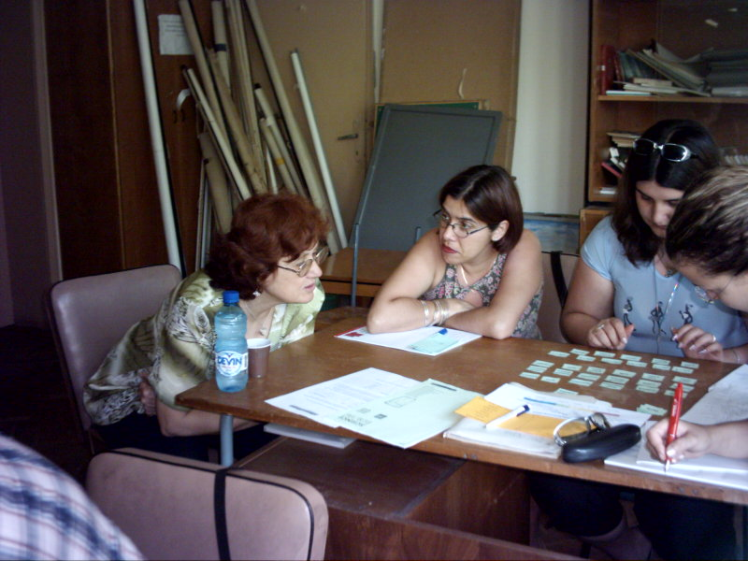

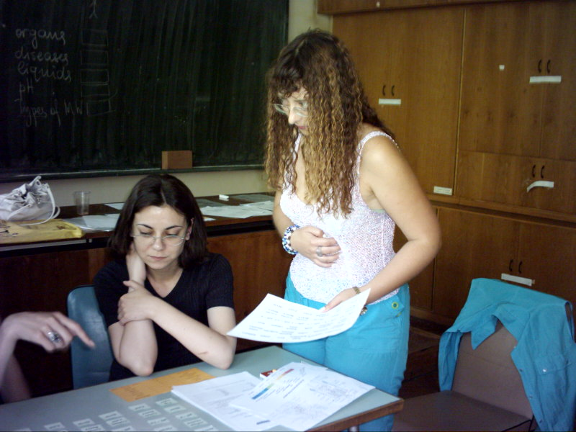

Water is a source of life,
Water is a state of mind
It is placid, running fast
It is beauty longing last
Pleasure for my senses
Inspiration for my dances!
(Merry Maria, Elvira – Experienced, Svetlana, Albena, Julia, Detelina)

WATER

It looks like a smile of a newborn baby
With pure and full of goodness minds,
Clear from the surrounding evil and
Troubles in life
It sounds like a bird flying free in the sky,
Singing under the sun
Not disturbed by the disastrous activities
Of the surrounding life
It smells like flower growing
In calm and sunny place
With odour of green and beauty nature
Reflecting one world of with clear environment.
It provokes the best sides of the person’s nature
To come out and show the world
How good we can be
If we want.
(Krassi – the Key)

Editors: Maria Koeva, Stefka Kitanova, Valya Angelova
Computer design: eng. Stanislav Shterev

