Communicating Information
Characteristic | Class
Height (cm) | Number of students
Less than 150
151 - 160
161 - 170
171 - 180
181 - 190
over 190
Skin colour | Number of students
White
Olive
Brown
Black
Eye colour | Number of students
Blue
Green
Grey
Brown
Hazel
Hair colour | Number of students
Blond
Red
Mid or light brown
Dark brown
Black
Ear lobes | Number of students
Attached
Unattached
Tongue | Number of students
Can roll
Cannot roll
Mid finger | Number of students
Has hair
No hair

Sharing Variation Data

Introduction
Comparisons of physical characteristics provide opportunities for students to examine differences and similarities between different countries and use the language associated with comparisons to describe these differences.
The procedure is quite straight forward for this activity:
- Students in different countries collect information and measurements on a range of characteristics (these can be selected by the teachers in advance)
- The class data is placed in a spreadsheet such as excel
- The excel files are swapped to share the information (communicated to the other country/countries)
- Students make comparisons (to communicate their analysis of the information)
There are two types of communication techniques used in this procedure. Firstly, to communicate the data in a format that can be interpreted easily by the students in the other country, this can be done using charts. Secondly, to communicate the interpretation of the information in words, spoken or written. The activity develops key skills in the areas of Information Technology and Language.

Collecting Data and Preparing the Charts
Students collect information on their own characteristics and make a written note of these. The data for the class is compiled in an excel spreadsheet. Details of the characteristics are shown in the table, but teachers can choose to adapt these to their own needs and those of the teachers in the other country. The only equipment required for the measurement of characteristics is a tape measure or metre ruler for collecting height data. Other characteristics which can be considered for an exchange are things like weight (provides interesting results but many students are self-conscientious about making their weight public knowledge), or shoe size (remember to use a standard such as European measurements).
It is of course possible to carry out the exchange of information without using excel, but this will require students to make their own charts and post them to the partner school. It would make an interesting activity to carry out in collaboration with mathematics or science if done in this way.
The charts are generated in excel and a template which includes the table shown above and the related charts, can be downloaded for this from [Stefka – please insert link to Fact2 here by typing in the web site address].

Making Comparisons
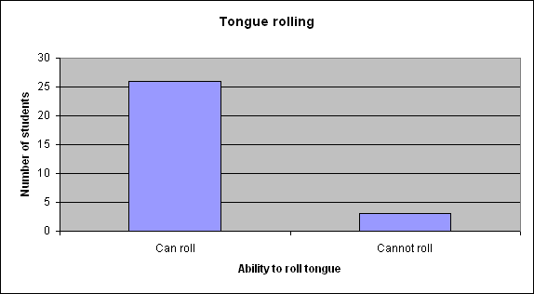
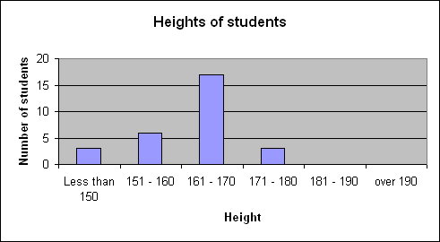

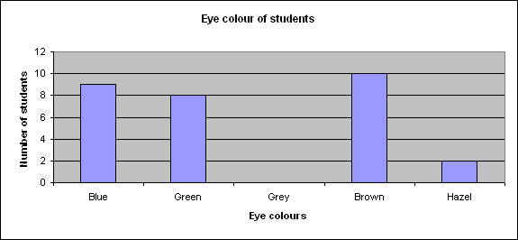
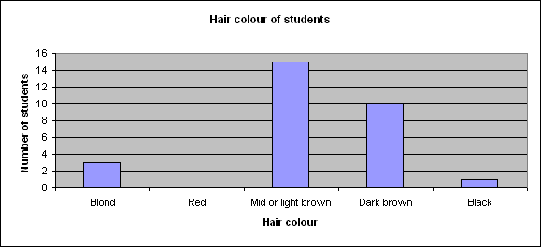

The charts above are examples from data collected by a class of 14 year old students from Penrice Community College, Cornwall, UK. Below are charts from their partner school for this activity, IES Sant Quirze, Spain:

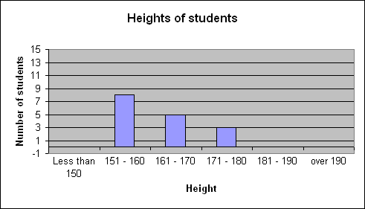
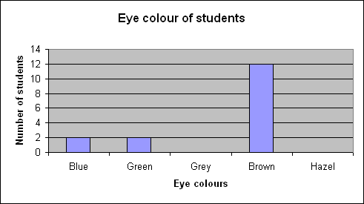
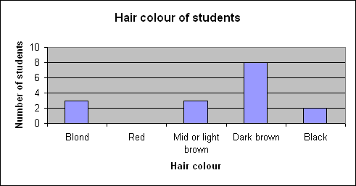
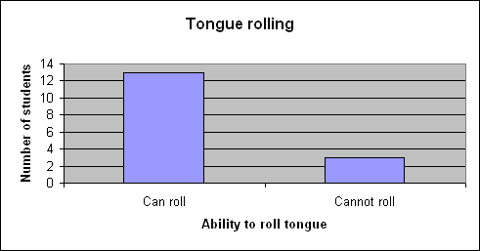

The easiest way of exchanging data is to send the excel file by email. Using the template requires very little previous knowledge of excel; the numbers can be entered into the table and the charts are generated automatically, the file is saved and sent to the partner school as an email attachment. In addition a photograph of the group can be sent as this will provided a concrete visual to link to the data, but it is not essential.
Comparing the Charts – the use of Language
Comparisons of the charts provide opportunities to develop the use of the following words or statements in language:
Roughly, generally
In addition
More than
Less than
While, but

The graphs above can be used to introduce the activity to students and give them practice in using the key words and phrases.
Examples of sentences:
In Spain most students have ……. hair, while in the UK, they are mostly ……….
There are more students with …….. eyes in the UK compared to the class in Spain.
The majority of students in both countries can ………..
Students in both countries seem to be similar in their ability to …………………
Generally speaking, the students in Spain are shorter/taller than the students in the UK.
In addition to blue and green, students in the UK also have …. and …. eye colours.
The number of students with heights less than …… is roughly the same in both countries.
Very few students in Spain and the UK cannot …….

Supertasters

The Supertasters activity is another example of variation between individuals, involving a short practical and analysis of data using excel. It is an activity which can be used to look at variation between individuals in the same class and develops skills in Information Technology, and the language of comparisons.

Collecting the Data
This is a fun activity involving a count to the number of taste buds on the tip of the tongue. The following procedure is taken from ‘The Secrets of Life’, a booklet produced to accompany the Royal Institution Christmas Lectures 2001, sponsored by GSK.
The Tongue Test
You’ll need some blue food colouring, a cotton bud or cotton wool, a mirror and a plastic reinforcement ring [these are often difficult to obtain and cutting around a hole punched in paper works just as well – make sure the holes used by all individuals are the same size].
Swab the blue colouring on your tongue. Make sure that you cover the tip. If you look in the mirror, you should see little pink circles that don’t stain. These are called fungiform (because they look like mushrooms) papillae and they are the structures on your tongue that hold your taste buds. Non- and medium- tasters look as though they have polka dots on their tongues. Supertasters have a tiled effect on theirs, and the fungiform papillae will be edge to edge on the tip of the tongue.
Now place the [paper] ring flat on your tongue as near to the end as you can get it. Count the number of pink circles inside the hole of the ring. Make sure you only count the unstained pink circles – other bumps on your tongue are different kinds of papillae and don’t contain taste-buds. If there are 25 or more pink circles in the ring you are a supertaster; between 5 and 10 and you’re a non-taster; the in-betweens are medium-tasters.

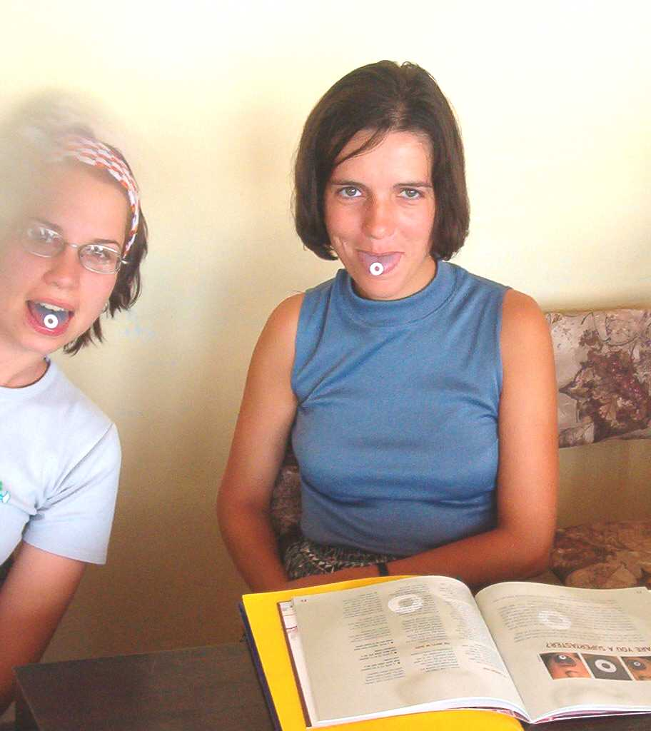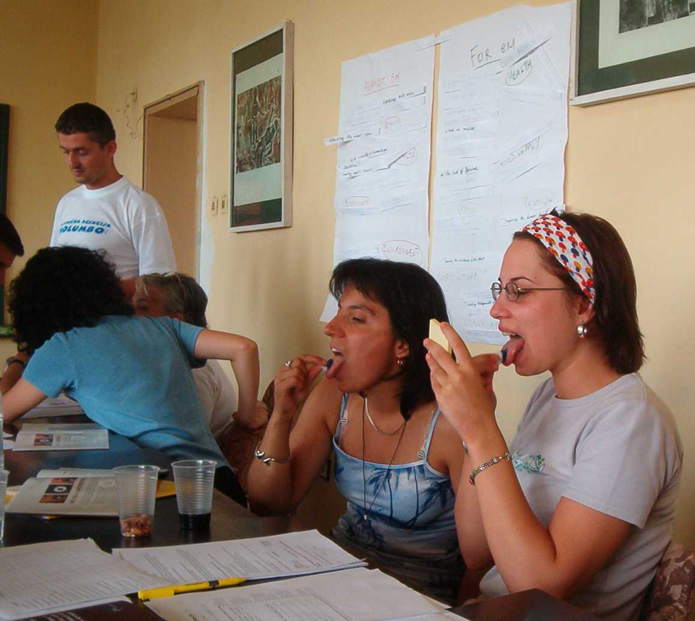

Using Excel to Produce Charts for Analysis
The following instructions use the Supertasters as an example for producing charts from data in excel. The results used are from the working party in Varna.

- Open excel on the computer
Name | Number
Keti Tomovska | 24
Marianna Tzaneva | 7
Renata Marcova | 15
Su Ping | 10
Eszter Veszelinov | 16
Albena Hristova | 19
Anelia Hristova Chakarova | 19
Dobromir Dimitrov Vetsov | 8
Drazen Dragovic | 9
Eva Spalj | 13
Lily Samurkova | 15
Stefka Kitanova | 36
Tatyana Gancheva Tusheva | 17
Dimitriyka Dimitrova Boeva | 20
Doina Teodoroviai-Brasov | 13
Elka Goranova | 19
Lyubov Dombeva | 35
Maria Iordanova Dimitrova | 12
Mihaela Serban-Buzan | 25
Milena Ivanova Milkova | 20
Tatyana Vancheva Vancheva | 12
Trentinné Benko Eva | 26
Denitsa Dimitrova | 16
Rossitza Popova | 20
Jacquie Ashton | 21
Petzanka Yonova | 15
- Click in cell A1 (column A, row 1) and type the heading for the first column – Name
- Click in cell A2 and type in the heading for the second column – Number
- Under the first heading, type the names of the individuals taking part in the experiment
- Under the second heading type the number of taste buds for bitter taste found on their tongues
- Click on cell A1 and hold the right mouse button down as you drag the cursor over the table to the bottom of the second column (do not include extra cells, only those containing information). This highlights the table.
- Click on the chart wizard in the standard toolbar at the top of the screen
- Select column, bar, pie or doughnut for the chart type and click next
- Check that the chart looks appropriate and click next
- Write in the title and labels for the axes. Click the legend tab and remove legend.
- Click next and then finish

The chart should appear on the excel sheet next to the table and it is possible to change its size by clicking inside the box containing the chart and then holding the mouse button down over the small black square on the corner (a double arrow will show when you are in the right place). It is sometimes necessary to do this if all the names do not appear along the x axis due to lack of space.

Reasons for Using Charts
Ease of comparison of data – the differences can be clearly and quickly seen without having to scan through numbers.
Clear presentation – charts can be copied and pasted into documents (such as word) or presentations (such as PowerPoint).

