Macmillan ICT Workshop (Nov 21st, 2008)
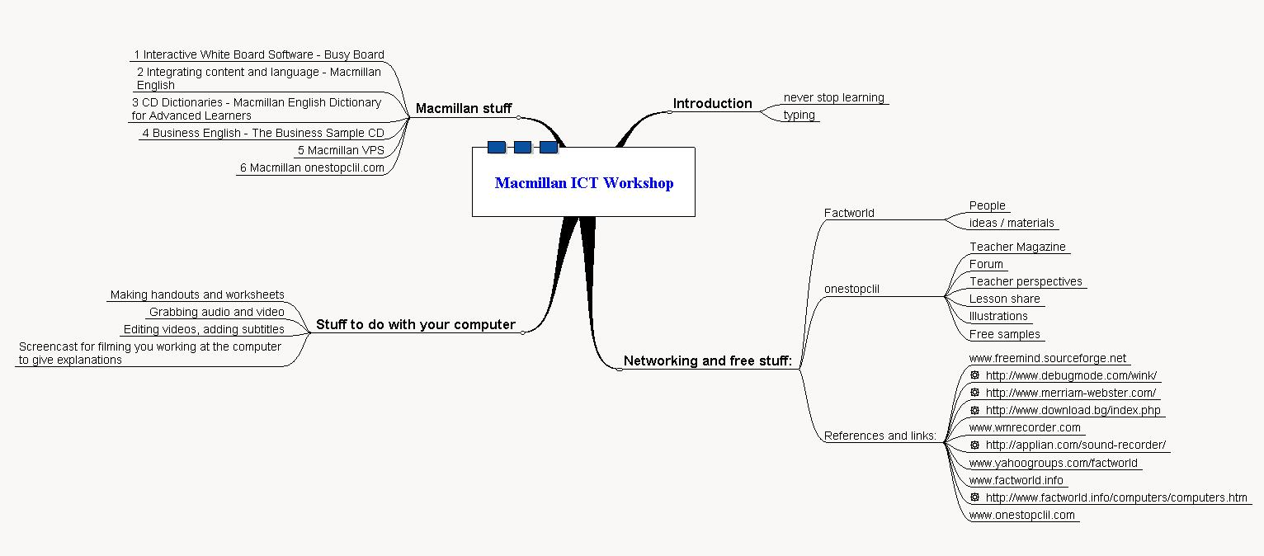
Introduction - never stop learning

How to type: Put your fingers on the middle row of letter keys with your forefingers on F and J, your thumbs on the space bar. Only move those fingers which are closest to the keys you want to type. If you do a google about typing speed, you'll find that an average speed for a two-finger typing non-professional is below 20 and anyone with a bit of practice can get up to between 20 to 40 words per minute. Secretaries work at around 65 to 75 wpm, advanced skilled typists can perform at 120 or more wpm. The point, though, is not to make mistakes!

http://www.powertyping.com/typing_test/typing_test.shtml

Macmillan stuff

1 Interactive White Board Software - Busy Board
Animation, text and sound - Listen, read, repeat, pause, repeat.

2 Integrating content and language - Macmillan English
Primary course bringing content and language together.
Handout - watch and make notes

3 CD Dictionaries - Macmillan English Dictionary for Advanced Learners
Lots of words and pronunciation.

4 Business English - The Business Sample CD
Really good use of video clips and add-on activities.

5 Macmillan VPS
Science VPS - word trees, total cloze and word list, illustrations.

6 Macmillan - onestopclil.com
Teacher Magazine, Forum, Teacher perspectives, Lesson share, Illustrations, Free samples

Stuff to do with your computer

- Making handouts and worksheets
Paint is a good simple software for tidying up pictures to use in handouts.

- Grabbing internet video and audio
You can get hold of masses of audio and video for use in the classroom.

(Idea - get the students to find a movie, download it, do the editing of a movie (with subtext) to present to the class)

- Editing videos / audio, adding subtitles
You can insert text into video and audio so that as students watch/listen, they can see the text.
Handout - sequencing text on burger advert

- Screencast
Handout - errors, discuss, correct
What's the best way to use the technology to deal with material like this?

Networking and free stuff:

Factworld - There are lots of people here and lots of free stuff and ideas - DIY software (Hidden Text, SWF, simple concordancing, matching, hyperlinks)

Macmillan onestopclil - (lesson share competition NB, there is less competition in onestopclil at the moment!)

NB - next and last session for this year, will be 'bits and pieces' and this will include, among other things, 'The Tao of Lesson Planning'.

References and links:

Free minmapping software - FreeMind - www.freemind.sourceforge.net

Free screencast software - Wink - http://www.debugmode.com/wink/

Free online dictionary with pronunciation - http://www.merriam-webster.com/

Free video grabbing software - Vloader -http://www.download.bg/index.php?cls=program&mtd=default&id=431360

Paid software for grabbing video - WM Recorder - www.wmrecorder.com

Free audio grabbing software - Freecorder - http://applian.com/sound-recorder/

www.yahoogroups.com/factworld
www.factworld.info
http://www.factworld.info/computers/computers.htm
www.onestopclil.com

