1 Hobbies questionnaire

Hobby  Name | Books | Music | Sport | Collecting | TV

Students fill in the table for with their own hobbies

2 Asking your partner on hobbies

Students ask a partner set questions (the students only to give one answer)

Examples:
What books do you like to read?
Possible answers – detective stories, thrillers, historical books, romance, magazines, comics
What music are you keen on?
Possible answers – pop, metal, rap, classical, rock, jazz
What sports do you go in for?
Basketball, football, volleyball, running, fishing, cycling
Do you collect anything?
Stamps, postcards, stickers, badges
What TV programmes do you like to watch?
Documentaries, drama, comedy, films, soap operas, cartoons

3 Recording a hobby survey

The teacher gives students time to question their partner and be questioned and then with a portable cassetter recorder or digital voice recorder chooses 5 students to retell their hobbies answering the questions above given by the teacher.

4 Listening to hobbies

Hobby  Name | Books | Music | Sport | Collecting | TV

Students (from another class) listen to the recordings of students’ hobbies prepared by the teacher and fill in the table with the correct information.

5 Collecting class info on hobbies

The teacher places sheets of paper on the walls of the classroom with the titles of the hobbies of the children in the class. The children then have to go and write their information on the sheets, and then when they have finished, sit down and wait for everyone to finish.

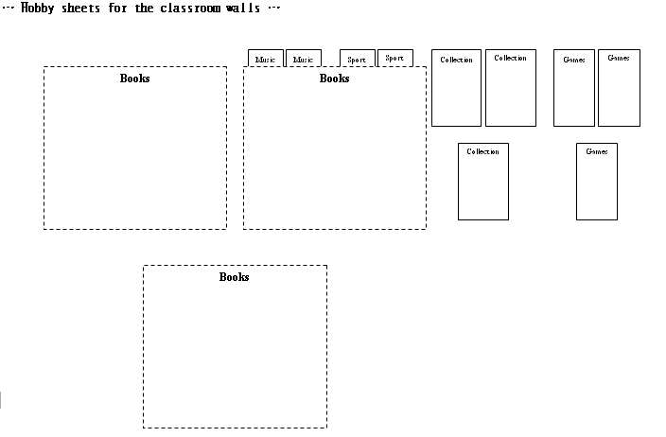

6 Gathering the hobbies data

The teacher collects the sheets from the walls and then places the students in groups (3-5 students per group). Teacher hands out the sheets, one per group. Students read the data on the hobbies sheet and ‘summarise’ the information, for example ‘detective stories – 5’, ‘football – 2’ etc.

7 Presenting hobbies data

The teacher stands at the board and asks the group to feed back their information. The teacher puts the information in ‘data circles’ on the board. Students copy the data circles into their notebooks.

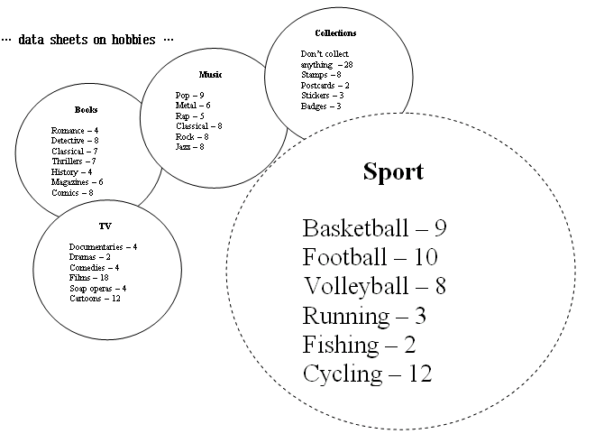

Homework

Students write one sentence for each of the data circles, for example, ‘9 people like to play Basketball’, ’10 people prefer football’, ‘8 people go in for volleyball’, ‘3 people go running’, ‘2 people like to go fishing’, ’12 people are keen on cycling’.

8 Comparing hobbies data

(H/WK – teacher asks for volunteers to read out their homework sentences while pointing to the data circles on the board)

In a different class (Class 2) the teacher writes up the data circles from Class 1 and students copy them into their notebooks.

The teacher gives some examples for teaching the compartive form, and superlatives:

More people in Class 1 play football than in Class 2.
Most of the people in Class 1 prefer cycling whereas the most popular hobby in Class 2 like to play … volleyball ….

…plus other examples…

Then in pairs, teacher tells students to write one sentence for each of the hobby groups to compare the two classes.

A number of the students read out their sentences to the class and rephrases, corrects where necessary.

(H/WK – students write a comparison of the two classes including one sentence for each hobby group)

9 Whole class hobbies games

Teacher prepares 20 words from the lesson studied and plays the team word guessing game to revise important words.

