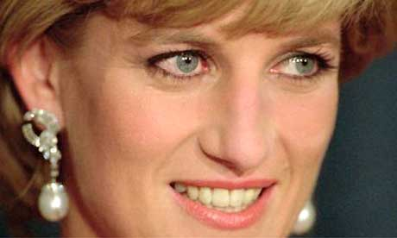
Road Safety in Bulgaria

Princess Diana died in a road traffic accident in Paris, France on August 31st 1997. A lot of people remember what they were doing when they heard the news. Over 3 million people went out on the streets of London during the funeral ceremony.
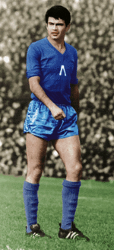
There are many examples of famous people involved in car crashes in Bulgaria. Georgi Asparuhov, Gundi, died when driving his Alfa Romeo sports car at speed near Botevgrad. He drove his car into a ZIL lorry and the passenger travelling with him was also killed.
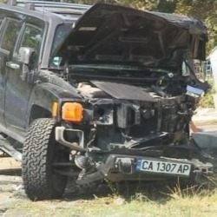

Kiril Marichkov was responsible for the death of another person while drunk in control of his car on the ring road outside Plovdiv. Maxim Staviski is the latest Bulgarian celebrity to have driven his car, a Hummer, while under the influence of alcohol and crashed. This resulted in the death of another person.
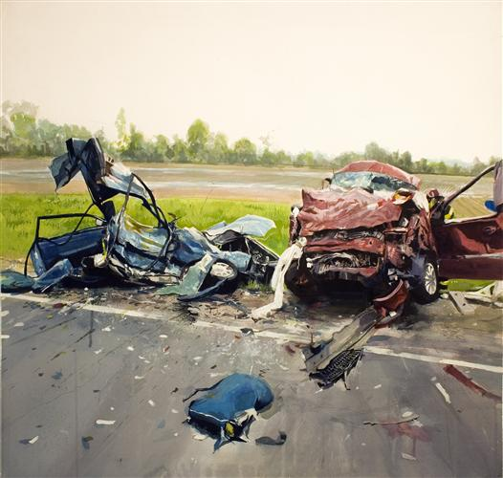
The famous get into the headlines in Bulgaria for drinking alocohol and driving, but there are over a thousand ‘anonymous’ deaths caused every year on the roads in Bulgaria. It can be dangerous to be out on the road in Bulgaria. According to a World Bank survey the number of road accident injuries and deaths has increased steadily from 2002 to 2006.

