BETA Conference, Veliko Tarnovo, 24th April, 2010

Content projects for language learning

Design Build Test Observe Present

Let's Launch a Rocket:
by Dobromir Vetsov dobriteacher@yahoo.com & Keith Kelly keithpkelly@yahoo.co.uk

Hints and tips for a better rocket:

Make sure you bear in mind the friction that will occur if your rocket body is too tight, or too loose, and also if your nose cone is not fixed in place properly it is likely to simply be blown off!
What about length? Will your rocket fly better with a long body or a short one?
It's a good idea to leave the plastic tube inside your rocket while you are sticking it together, and while you are fixing the nose cone in place.
Don't forget the design! There will a prize for the best rocket flight and design will be a factor in the decision of the judges!
Try experimenting with the size and shape of your fins. Will your rocket flight be more successful with bigger or smaller fins?
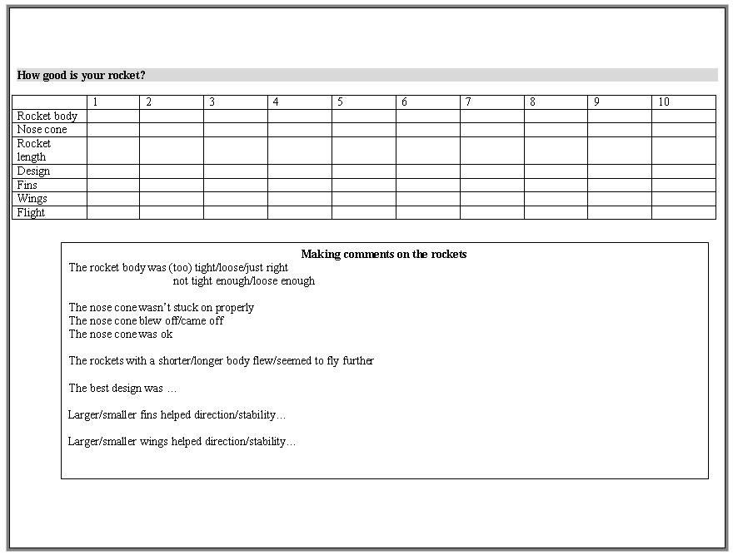
What about wings? Will your rocket fly longer and further with wings? If you decide to build wings for your rocket what shape should they be? Long and thin or short and wide? You can build whatever you like!

Just to recap!
Friction - tight or loose body!
Fix the nose cone!
Body length?
Use the plastic tube!
Design!
Fins - size and shape!
Wings?

References:
- Middlesex University booklet on all kinds of rockets to build in school http://www.mutr.co.uk/images/Rocket_Factory.pdf
- 24 paper airplanes to create and fly http://www.paperairplanes.co.uk/
- There are many internet 'bridge building' challenges - http://42explore.com/bridge.htm
- Programme with wide collection of content projects - www.scienceacross.org
- Network for sharing ideas - factworld@yahoogroups.com
- Website for sharing news - www.factworld.info
- There are lots of 'experiments' following above model at - www.onestopclil.com

