Message 8 - Archiving, sharing and collaborating on files (02.03.11)
Dear colleagues,
We had a very successful skype video chat on Monday between my group and the Rio group. There is a short clip available here:
http://www.box.net/shared/yi8axfo4v5
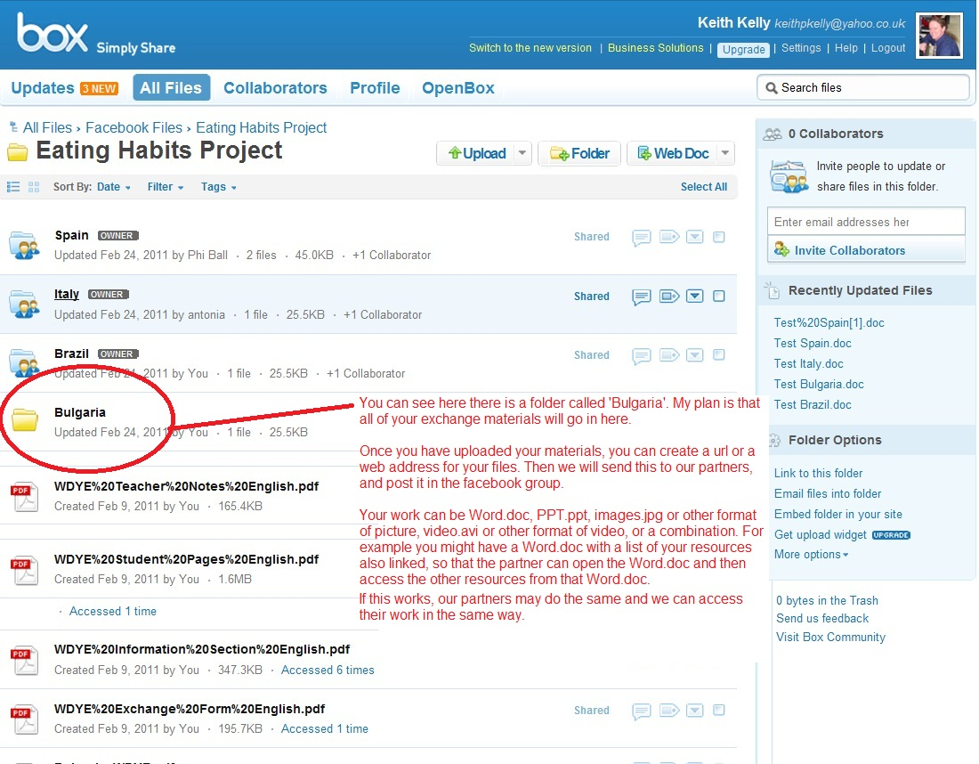
I’ve posted instructions to the facebook group on using box.net with a view to my students using this medium for publishing and sharing their work on the project.
Step 1

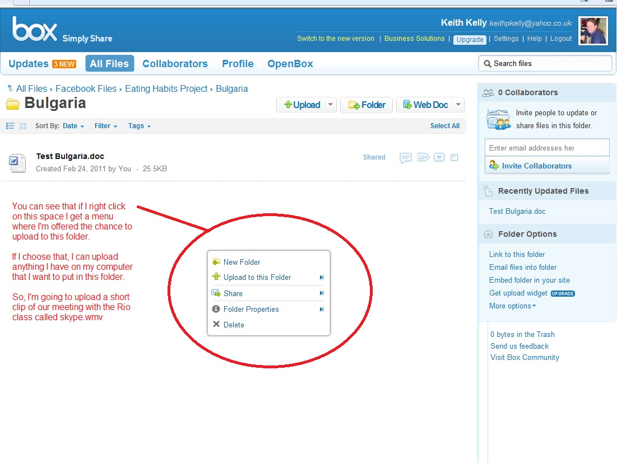

Step 2
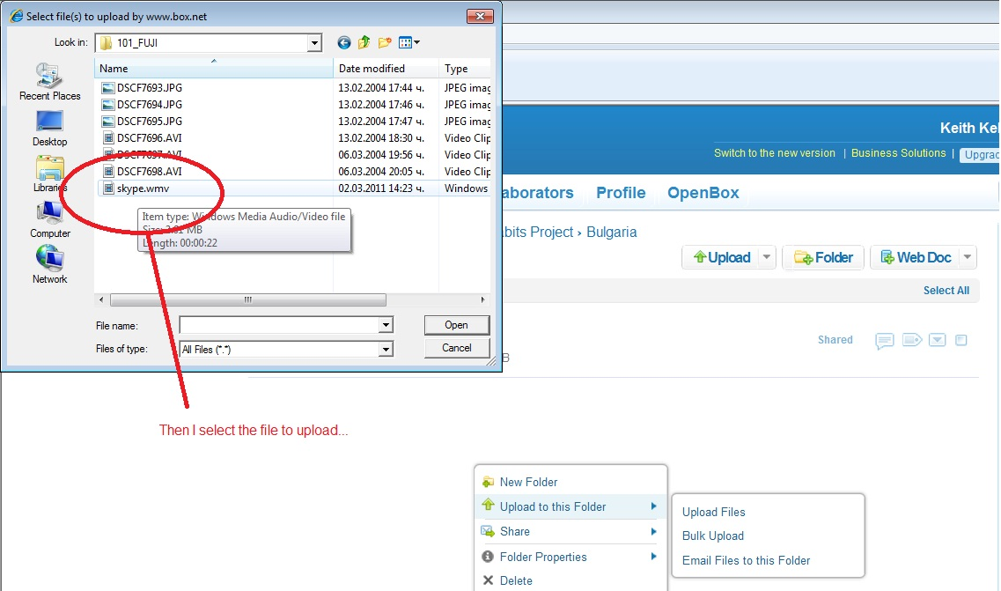
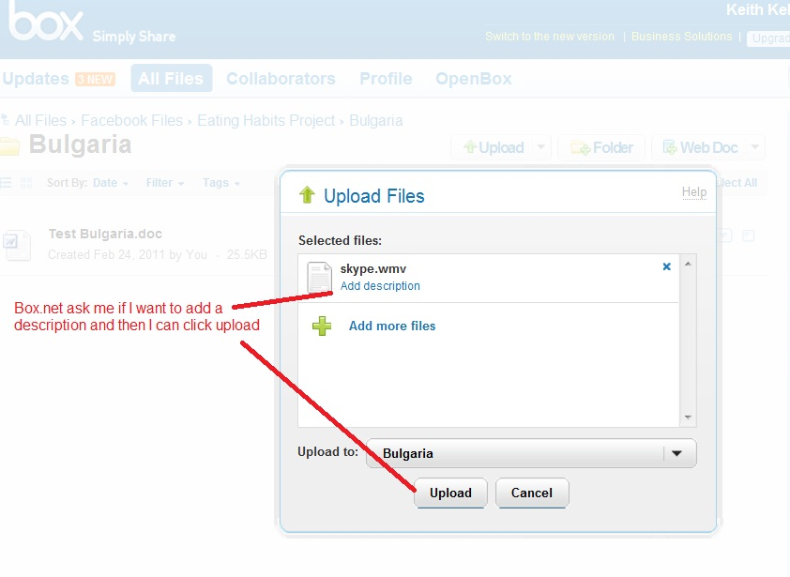
Step 3

Step 4

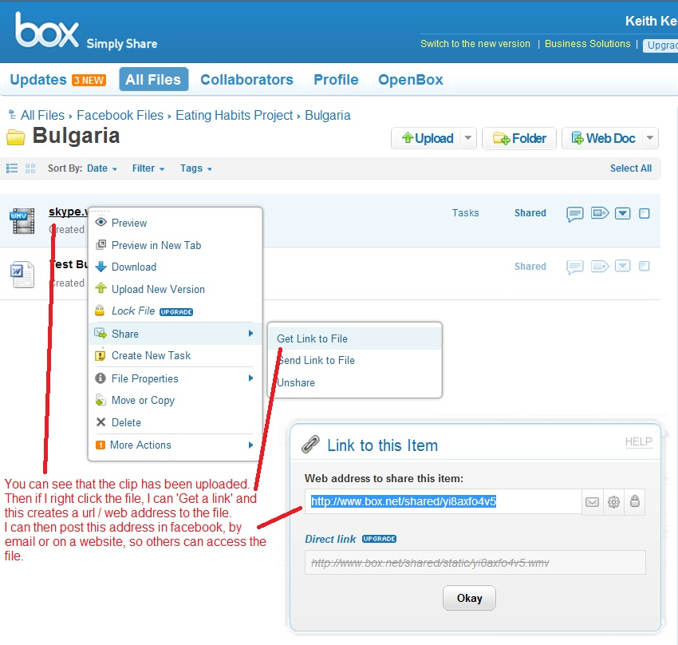

Step 5
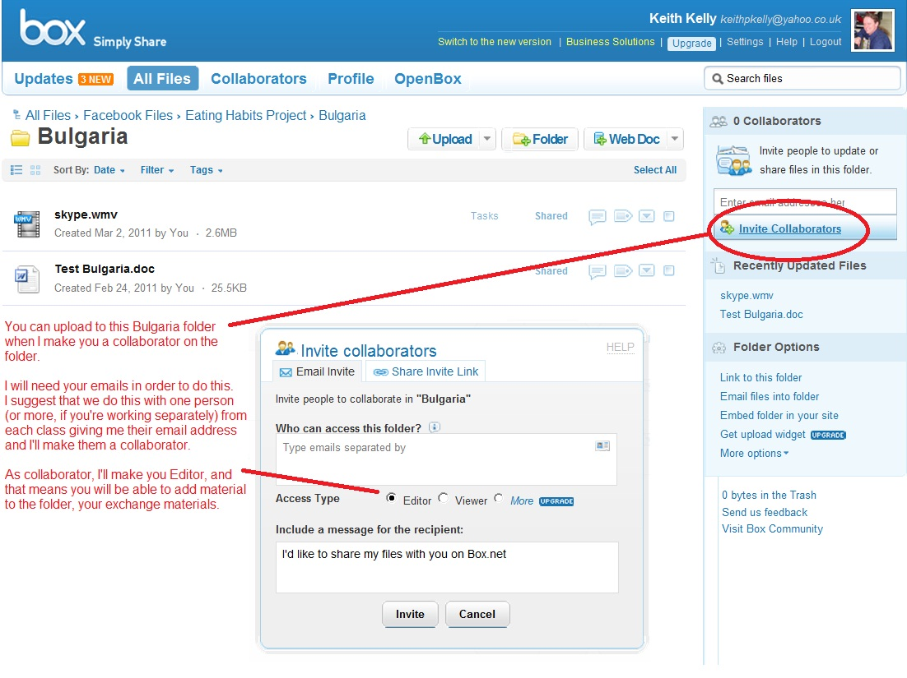
Step 6

I think this is a good way for us to share and get students sharing their work. Let me know what you think and if you have other ideas, or any problems or questions.
Best wishes
Keith

