Message 5
20.02.2011
Hi there
I was asked to provide some suggestions about working with the exchange forms a little while ago.
Sorry it’s taken me so long to get round to it. Here is a document with a number of suggestions. Hope it helps.
Basically the idea is a) collect a variety of interesting info and b) present it all in engaging varied ways.
Let me know if you need any help!!!!
Best wishes
Keith

Idea for working with the exchange forms
I promised a week ago to write a document with ideas about things to do for collecting information for the exchange. Sorry it’s taken so long. Here are some suggestions:
1) filling in the sections of the exchange form and how to present results.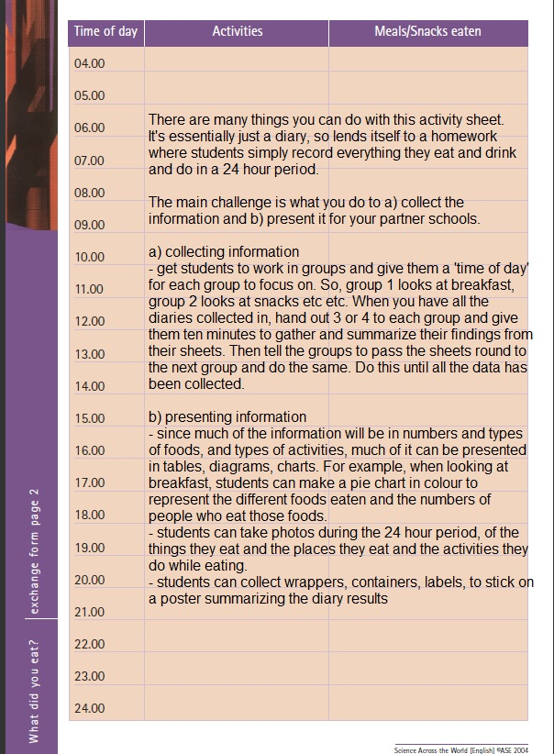
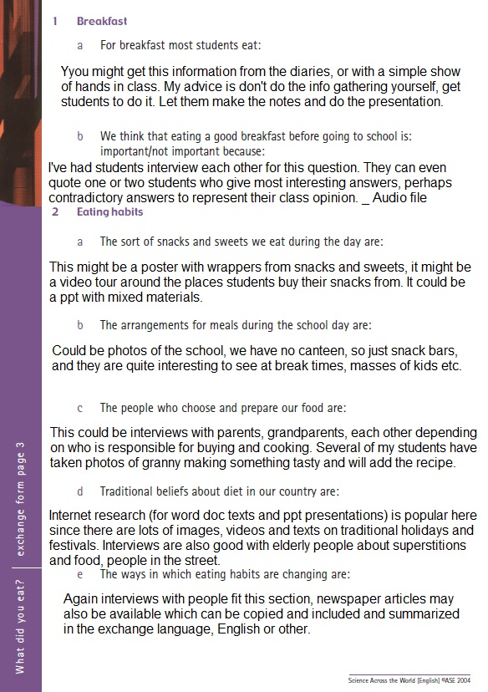



2) here is an ideas web from a colleague about working on food:
http://www.factworld.info/saw/saw_supps/food_things.JPG
3) The following are pages from this book on ideas for working with Science Across the World:
http://www.factworld.info/syw.pdf
Take a look at pages 24 to 31
here are three pages with 50 ideas:
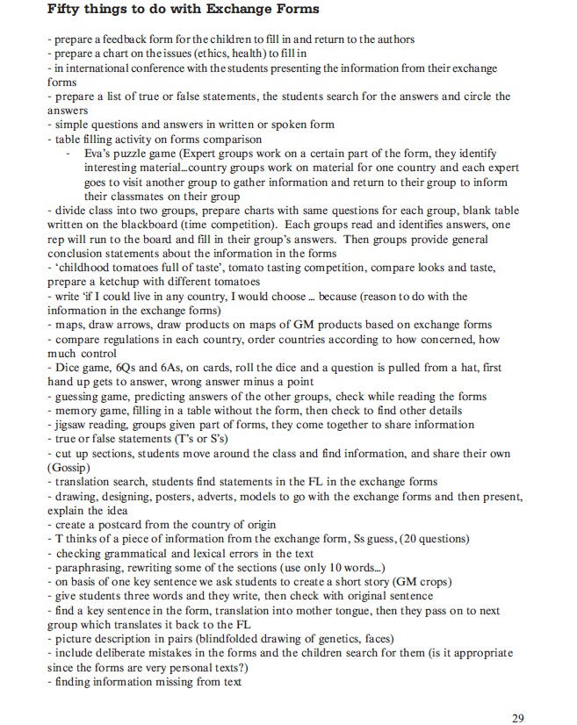

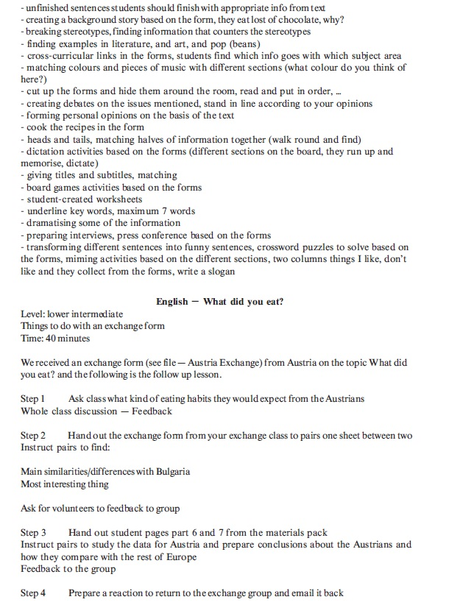

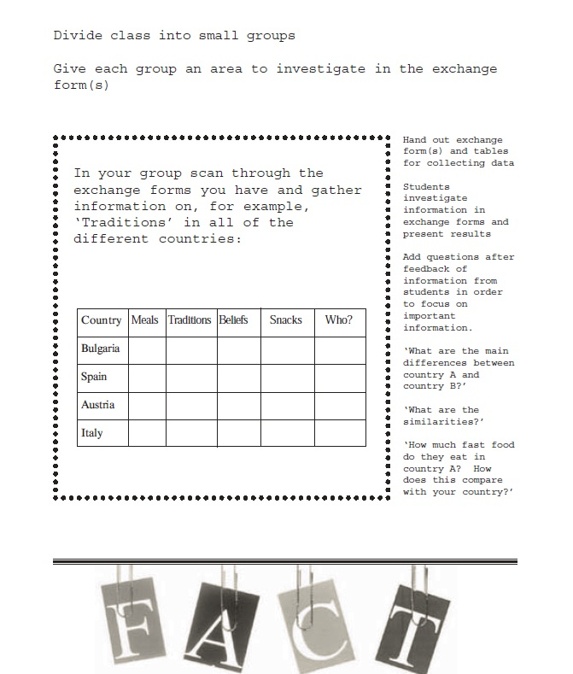
Hope this helps
Keith

