Topic: Moments

Read the questions and choose the best answer from those given.

The diagram below shows a model crane with a movable counterbalance.
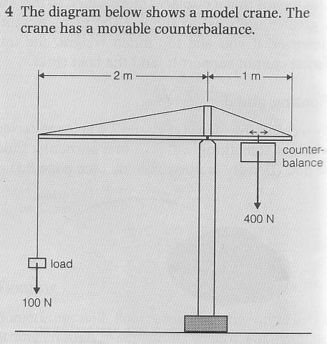
1 Why does the crane need a counterbalance?
a To counter the weight of the load
b To combine the weight of the load
c To collect the weight of the load

2 Why does the counterbalance need to be movable?
a If it is movable different loads can be carried
b If it is movable unlimited loads can be carried
c If it is movable the loads can be multiple

3 In the diagram, what is the moment of the 100N force about O?
a The moment of the 100N force about O is an anticlockwise moment of 200Nm
b The moment of the 100N force about O is an anticlockwise moment of 300Nm
c The moment of the 100N force about O is an anticlockwise moment of 400Nm

4 To balance the crane, what moment must the 400N force have?
a To balance the crane, the 400N force must have a clockwise moment of 200Nm
b To balance the crane, the 400N force must have a clockwise moment of 300Nm
c To balance the crane, the 400N force must have a clockwise moment of 400Nm

5 How far from O should the counterbalance be positioned?
a The counterbalance be positioned 0.5m from O
b The counterbalance be positioned 1m from O
c The counterbalance be positioned 2m from O

6 Where would you expect the counterbalance to be positioned if the crane is lifting its maximum load?
a If the crane is lifting its maximum load the counterbalance should be positioned 1m from O
b If the crane is lifting its maximum load the counterbalance should be positioned 2m from O
c If the crane is lifting its maximum load the counterbalance should be positioned 0.5m from O

7 What is the maximum load the crane should lift?
a The maximum load the crane should lift is 200N
b The maximum load the crane should lift is 100N
c The maximum load the crane should lift is 400N

