Zero Carbon City Exhibition, Beijing, China, Sept 4th to 11th, 2005
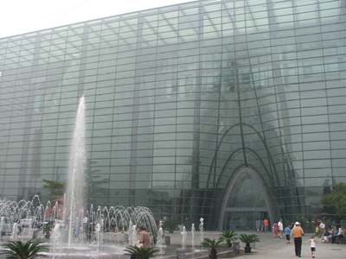
The Education and Cultural Section of the British Embassy in China (www.britishcouncil.org.cn) opened the ZCC Exhibition at the Planetarium Beijing on Monday, Set 5th, 2005 guests included Ian Pearson, British Minister for International Trade.

Beijing Planetarium

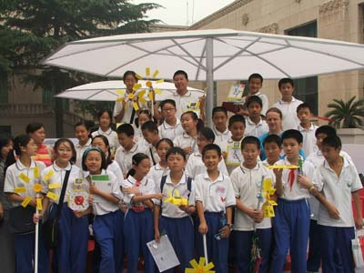
A group of 30 children from a Beijing Junior Middle School came for a workshop involving the construction of a solar-powered clock, a wind turbine and a ‘gismo’ of their choice as well the creation of a UV-warning badge which they wore throughout the day in the Beijing sunshine. Luckily we were protected by two large umbrellas.

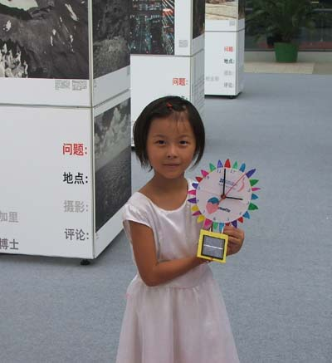

The activities were very busy and intensive and as always the children produced some wonderful inventions including a reproduction of a food mixer, a robot with twirling parasol, several attempts at solar-powered cars, planes, boats, as well as a ‘crazy face’ with spinning eyes and a ‘bingo box’.
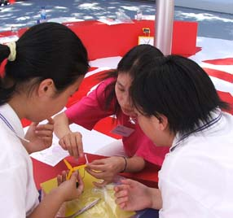
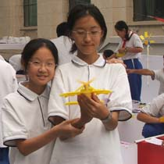
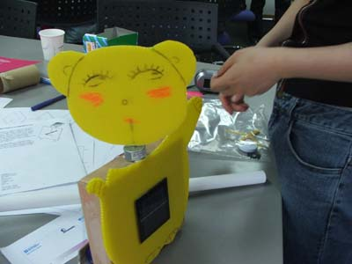
These activities are the creation of the Middlesex University Teaching Resources unit (www.mutr.ac.uk).

Zhoa Wei, Lili, Oliver and Wang Ping spent the day helping out and dealing with all of the fiddly bits the children had problems with. Many thanks to them.
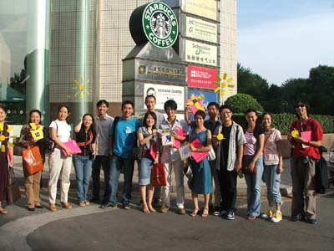
This day marked the opening of the Exhibition tour in China but preparation has been going on for a long time. The day before brought 30 teachers and post-grad students together to work on the issues behind the Exhibition as well as getting their hands on the kits and considering potential problems.

Facilitators and teachers at the opening workshop

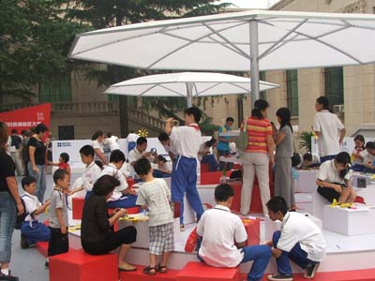

The third day of my facilitating the wrap around activities was again very intensive. We had a spot check head count at several points and the peak reached 60 participants. We were literally run off our feet.

Sunday, 10th September, 2005

Wonderful turnout today, I thought yesterday was busy, our on the spot head count gave 80 participants. Offically the biggest lesson I have ever been involved in!
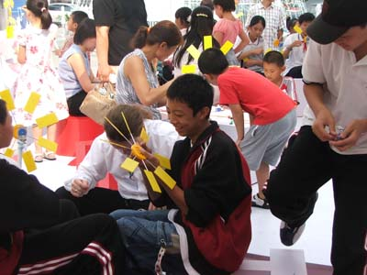
There was even a moment where we had to apologise and turn people away for the time being as we gave our attention to a group of Beijing school children who had booked a ZCC wrap-around activities session.
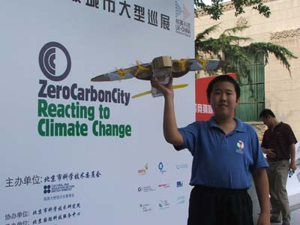

Wang produced the biggest solar-powered aeroplane I have yet to witness, and all from recycled parts and materials.

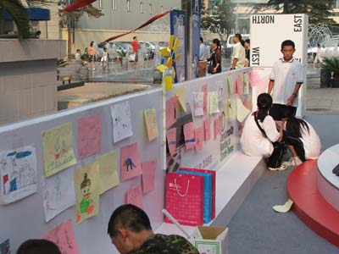
We busied the passing visitors big and small with painting and drawing and a mini exhibition within the ZCC exhibition quickly appeared.

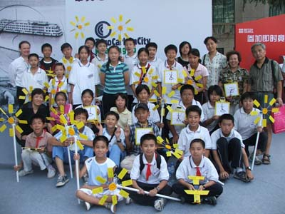

Many many thanks to all of the BC ZCC exhibition facilitators for all of their help and patience in dealing with the crowds so well and running around for things to keep the show running smoothly.

On to Shanghai…

Best wishes
Keith

Keith Kelly (Education Consultant)
FACTWorld Coordinator (www.factworld.info)
NILE Associate Trainer (www.nile-elt.com)
SAW Consultant (www.scienceacross.org)

Home address: 20 Rose Valley, Norwich, NR22PX, UK
Home tel: 0044 1603610896
Mobile: 0044 778 2356776
Email: keithkelly@factworld.org

The Forum for Across the Curriculum Teaching - Supporting and Developing Content and Language Integrated Learning

