Schools Links UK - China

The Cultural and Education Section of the British Consulate-General in Shanghai www.britishcouncil.org.cn is running an exciting schools links programme where UK schools are partnered with Chinese schools to develop what is hoped will become a long term relationship.

Workshops for some of the schools involved in the programme were run in China on curriculum linking projects from September 20th to 23rd, 2005. Science Across the World www.scienceacross.org internet exchange projects were presented to the schools with a focus on student investigations on themes related to the daily lives of the children in both countries. The programme is a good way of moving beyond the ‘pen pal’ exchange between schools and developing real curriculum links where students exchange information and materials related to their studies and the real world.

How the Science Across the World programme of exchange works:

- students work through a themed project in school
- they investigate an area of their lives related to the topic and gather results
- they work on presenting their results for an ‘audience’, in this case a partner school in the UK
- students exchange their findings with their partner school and compare results
- ideally, this form of interaction with a partner school would move on to a new investigation and follow up exchange between the schools

Outcomes

In total we worked with 200 teachers and 150 students over the two weeks of activities. Some of the schools already had links with schools in the UK and along with new recruits much was done to boost the initiative thanks to the Science Across the World programme. We identified many key collegues to develop Science Across further in China and offer this free programme to more schools around the country. Many thanks to Mr Fan of the Putuo District for his enthusiasm and willingness to take the programme further in Shanghai and to all those people who made this such an exciting and memorable visit. I myself will be working with key partner schools back in the UK including the Essex group of schools linked with Jiangsu Province and will make contact with other schools and regions I know are linked with China and we’ll see what we can do to bring both sides into the Science Across family.

Thanks, especially, to the British Council in China for making this happen. It was a particularly effective initiative for many reasons not least because of the coordination involved in communication and organisation in putting on so many workshops with teachers and students.

The School Links Programme of acitivities in China

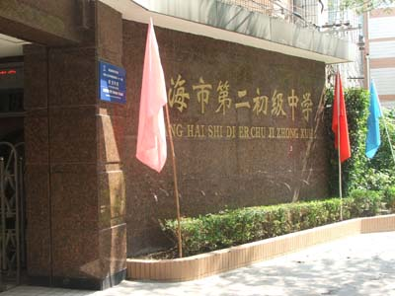
Tuesday, 20th Sept No. 2 Middle School, Shanghai.

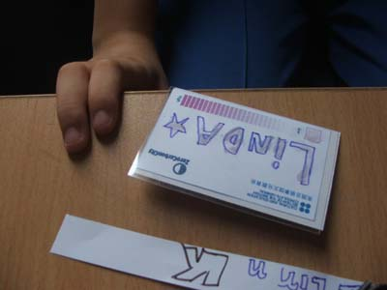

12-14 year olds at the Middle School carried out the ZCC Exhibition ‘Climate Change Kits’ activities as part of the week of events (kits available from Middlesex University Teaching Resources www.mutr.ac.uk).

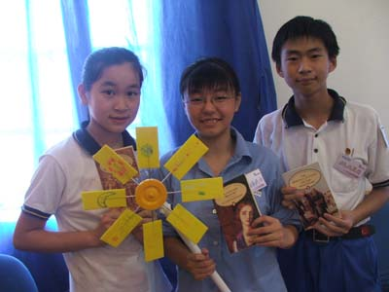

Children built all manner of solar powered gismos including solar-powered clocks with an environmental theme including UV-warning badges, aeroplanes, boats and cars, and also wind turbines in a practical lesson as a warm up to the teachers’ Schools Links workshop.

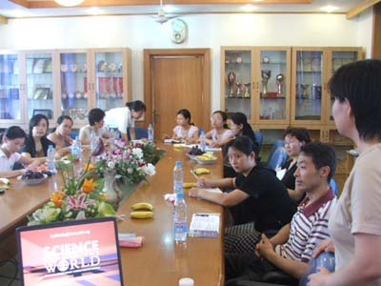
The teachers workshop was attended by 15 teachers from the schools in the area who are working with their partner schools in Norfolk, UK. The workshop focused on introducing the Science Across the World programme into the school curriculum and carrying out the research as a means of developing mutual understanding between children and teachers at the partner schools.

The teachers considered examples of culturally-specific investigations and activities for their own partnership which included Beijing students developing their own range of Chinese cosmetics in the classroom.
The afternoon saw us on a fast boat to Chongming Island and the Dongmen Primary School, the host of the next day’s activities.

Wednesday, 21st Sept Chongming Island

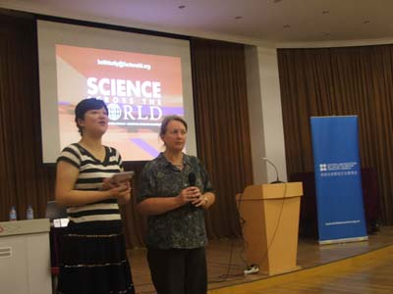
Chongming is a nature reserve to a variety of bird and other animal and plant life which is a wonderful example of the kind of context ideal for a Science Across exchange project. We discovered the delights of the Hairy River Crab!

Jane Henry of the British Council in Shanghai opens the teachers’ meeting…


We also caused quite a stir among the primary school children who seemed to enjoy having foreigners on campus.

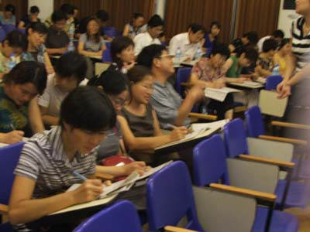
The school hosted a presentation to over 70 teachers from the island where a schools links initiative is being developed with schools in Cheshire with the help of colleagues at Salford University. Even with such a large group we managed to carry out some of the Science Across survey activities such as the ‘speed reaction’ test.

Children from the school will also be participating in the ZCC Exhibition with examples of their art prints.

A storm and choppy Yangtse River had us a little worried about the return to the mainland, but the storm passed quickly after knocking over several bicycles in the streets and flooding the waiting room at the port.
Thursday, 22nd Sept Jiangsu Schools
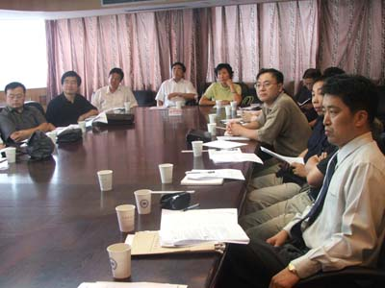
The next day took us by train across to the neighbouring province of Jiangsu where we were met the group of headteachers and deputy heads from schools linked with Essex schools. The event was hosted by the Jiangsu Provincial Education Department by Stephen He, Chief Officer for International Links at the division, and by his boss, Mr Yu.

The 15 colleagues were nodding in all the right places during the presentation when offered examples of ways for creating a rich exchange with a UK school.

Discussion on follow up revolved around problems to do with the heavy curriculum senior school students are faced with and how to accommodate the Science Across the World programme in such a situation. The discussion came up with a number of possible ways ahead including making use of the ‘hobby hours’ in the schools where students work in interest group focusing on investigation, an ideal context for Science Across work.

Friday, 23rd Sept The Nanjing Yuhuatai High School

The Nanjing Yuhuatai High School has 3000 students and is set in a beautiful campus will luscious gardens and a peaceful environment for hard studying. The school played host to our workshop for more DIY activities with students.
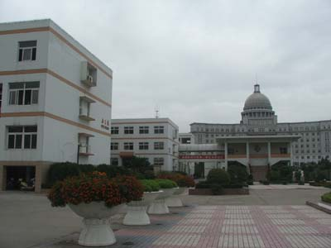

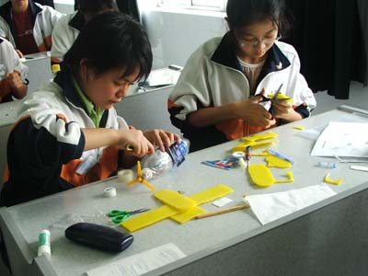

The students were 16 year olds and had plenty of ideas for their inventions and for constructing their clocks and wind turbines.

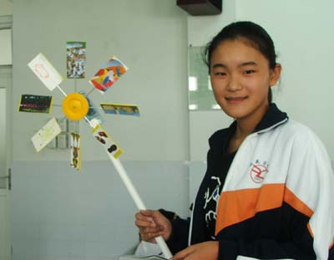
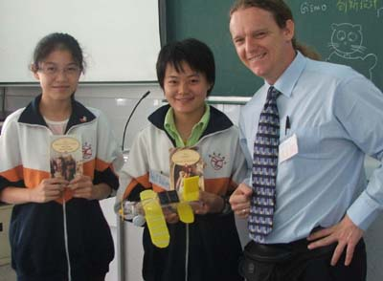

Choosing winners for the British Council prizes, sets of Penguin classics, was difficult but we concentrated on their team work and finally chose two excellent creations.

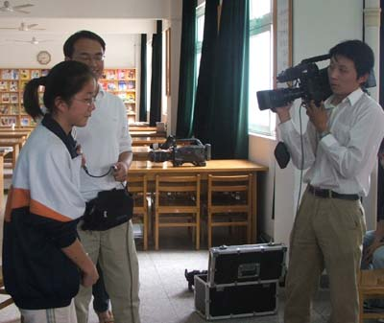

Small Talk, an English language programme from a provincial educational TV channel cam e to invterview us and the students presented their inventions and talked about the experience. This should mean that the initiative will go out to many thousands of viewers via the programme in Jiangsu Province.

Monday, 26th Sept Pudong New Area, Shanghai

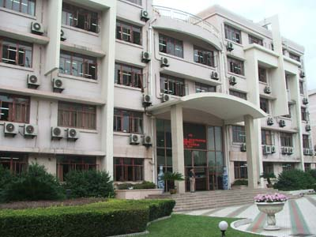
Went to the Jianping Senior High School in Pudong New Area today to work with teachers from the area looking to build school links in the UK, our hosts already with a link with a school in Kent…
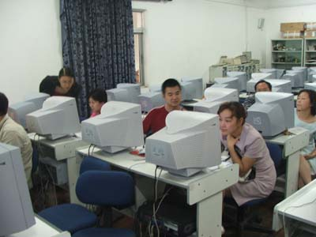

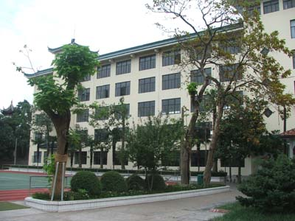
… and then on to the Ganlan Primary School, one of the oldest in the city and still with original city walls in its grounds.

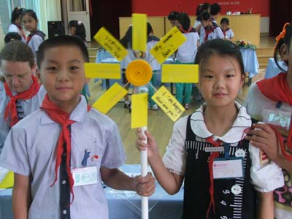

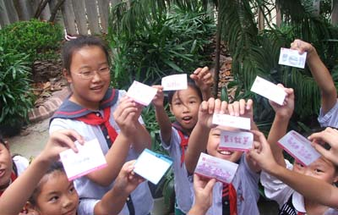
The children are following a bilingual system studying music, sport, art, and technology in English.

I’m not surprised that they didn’t have any problems, despite their age, with the science kits after seeing their own creative works presented to us.

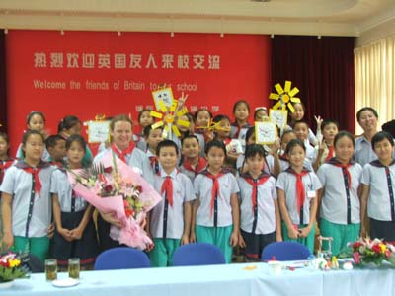

A wonderful group of children, and very enthusiastic and friendly staff. Many thanks to all at the school for their warmth and welcome.
Tuesday, 27th Sept Putuo District, Shanghai
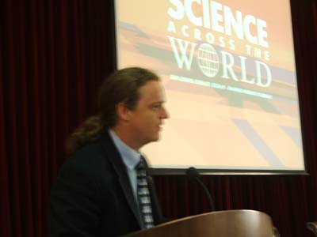
Putuo District Education Authority Teacher Training Institute hosted a meeting for 60 teachers looking to develop links with UK schools, some already with school links in Dorking and with schools in Lancashire.

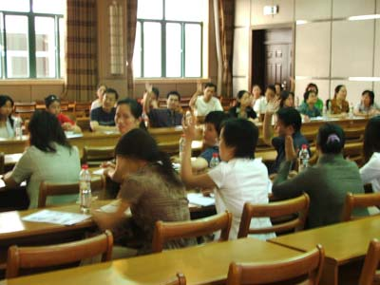

Mr Fan, Dep Dir for Education in the district was keen to exploit the Science Across the World programme, and will pilot Science Across in schools and look into the possibility of translations of materials into Chinese, and encourage schools to develop their own investigations. I will send Mr Fan the templates for SAW materials to help him do this.

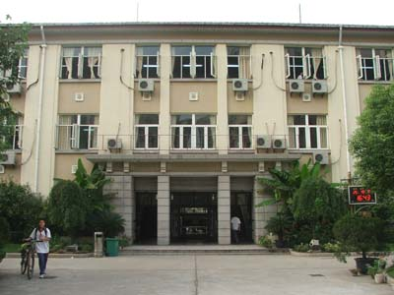
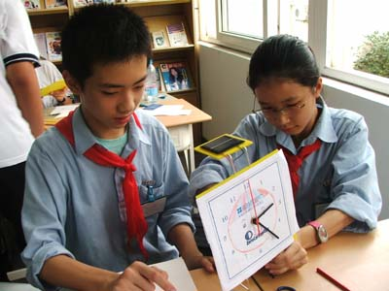
The Lan Tian Middle school was a delight, already using the ‘hobby hours’ to do creative project work, the students were more than ready to get into the MUTR kits with gusto.

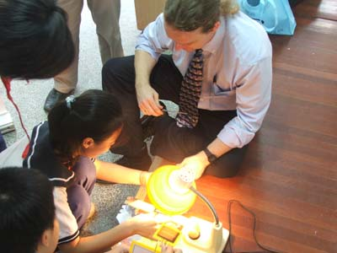
With no sunshine we had to resort to other measures…

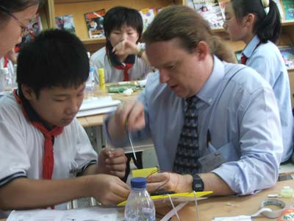

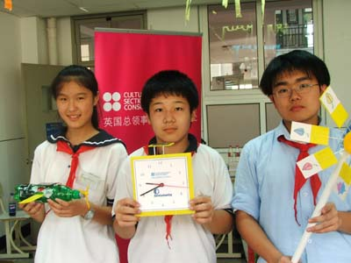

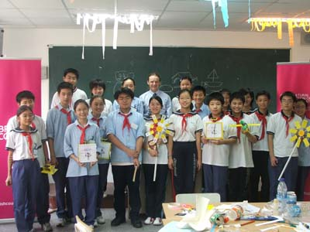
Winners and the whole group…

Wednesday, 28th Sept Luwan District, Shanghai
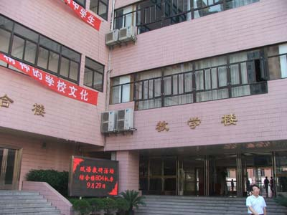

Luwan Senior High School linked with the Colne School in Essex, UK played host to our visit today.

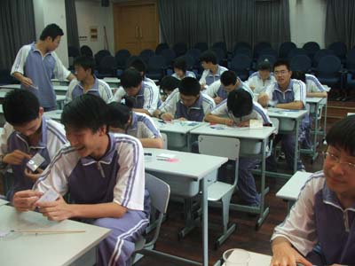
We had a workshop with Senior 1 students from the school, aged 16-17 years and who exhibited a wonderful imagination for the creative side to the design and construction of the MUTR kits.

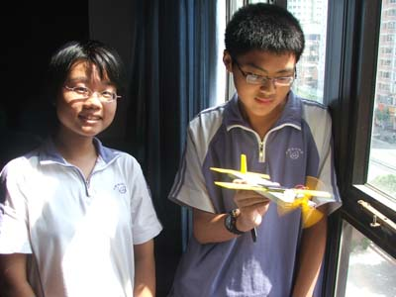

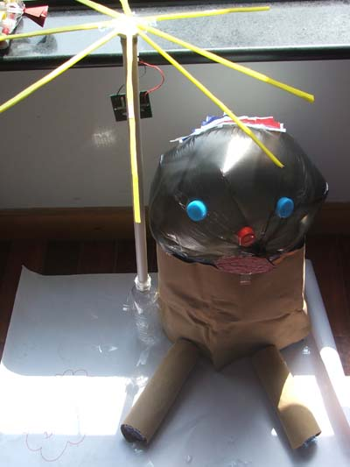

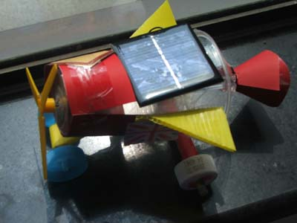
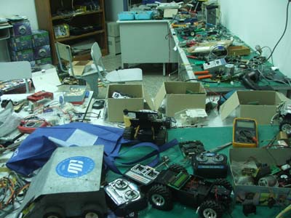
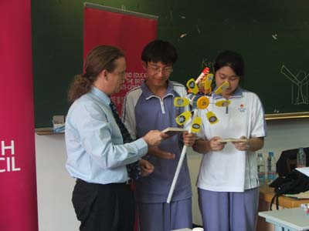
Dasheng and I were given a tour of the school and shown some of the great projects the school is involved in including the robotics workshop and the ‘Odyssey of the Mind’ project for integrating talents within students through Science and Arts.

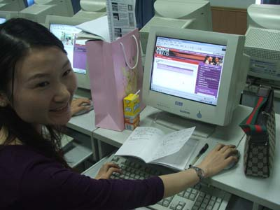

20 teachers from the Luwan district senior high schools and middle schools came to the workshop on Science Across the World and were keen to make the most the programme offers for developing effective links with schools not only in the UK but all over the world.
Science Across the World Workshop


- Introduction to SAW

  - What did you eat? Daily diet
  - Things to do with an exchange form
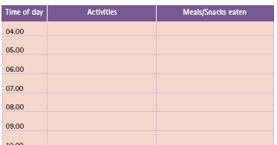

Colleagues look at the What did you eat? exchange form and consider the value of such cultural comparison for school links projects.

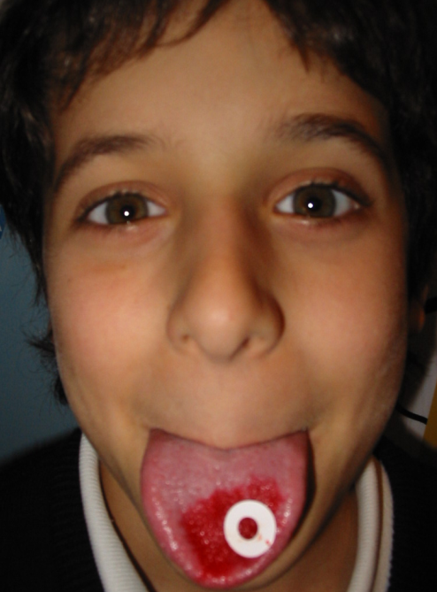
- Looking at sample Science Across topics

Talking about Genetics Variation
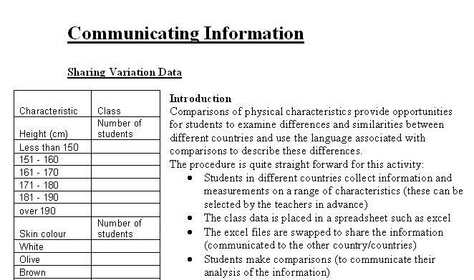
  - Collecting and Communicating Information

Biodiversity around Us biome survey
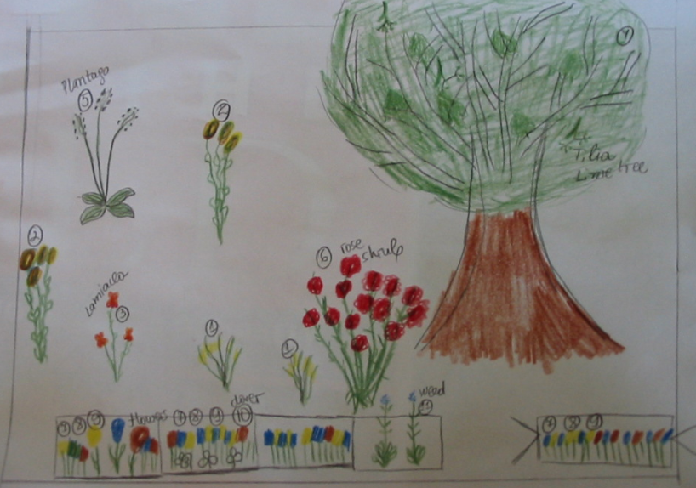
- Biodiversity map of China

Students choose a local area and plot out a map of the biodiversity found there…

Domestic waste Recycling action plan
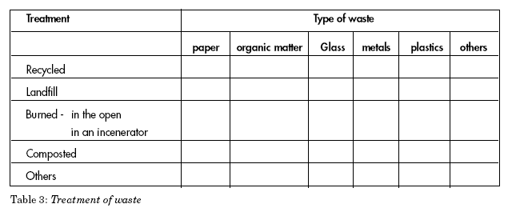

Students examine the treatment of domestic waste and consider introducing their own school recycling action plan…

Keeping Healthy Injury deaths in young people
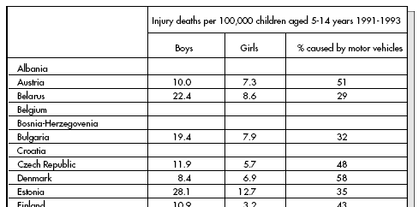

Science Across the World offers a wide range of information pages relevant to the topics being studied…

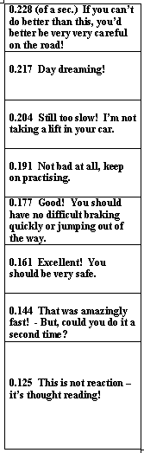
Road Safety Reaction speed test

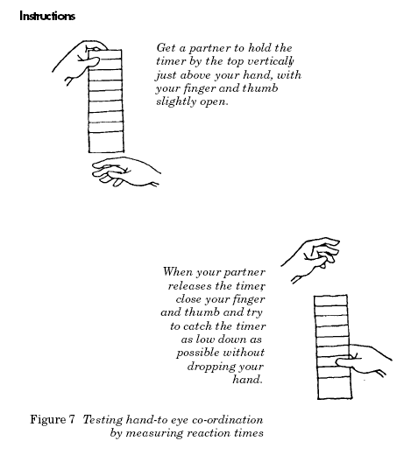
Students carry out practical tests to contextualise the science themes at the heart of the topics in the materials packs. These include the ‘speed reaction tests’ where students consider the dangers on the roads in general and the importance of reaction when thinking about safety.

Chemistry in our lives cosmetics production

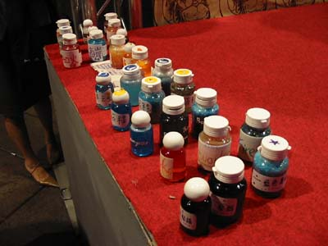
students produce and market their own chemical products with a local flavour, such as hair gel, shampoo and bath salts…

- Signing up to Science Across the World
  - The Science Across website

Teachers went through the signing up process on the website…

- Following up

Teachers were asked to consider how they could use the Science Across programme and what to do with an exchange partner.

Discuss in groups, plan time scale, send to partner schools.

It was a very very full week of school visits and workshops with both teachers and students. I have been impressed with the British Council management of the initiative and many thanks go to Dasheng for her impeccable organisation skills, as well as to the schools themselves, for their enthusiasm and warmth.

Can’t wait to come back and see how they are getting on ‘school-linking’.

Best wishes
Keith

Keith Kelly (Language Education Consultant)
FACTWorld Coordinator (www.factworld.info)
NILE Associate Trainer (www.nile-elt.com)
SAW Consultant (www.scienceacross.org)

Home address: 20 Rose Valley, Norwich, NR22PX, UK
Home tel: 0044 1603610896

Mobile: 0044 778 2356776
email: keithkelly@factworld.org

The Forum for Across the Curriculum Teaching - Supporting and Developing Content and Language Integrated Learning

