Celebrating Science in China
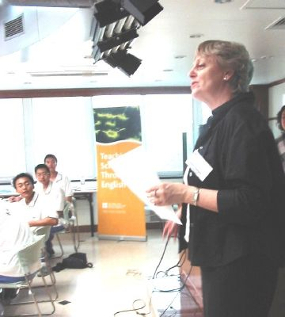

The Cultural and Education Section of the British Embassy, Beijing, China

Day 1 – Saturday July 10
Designing and launching rockets at the Number 4 High School, Beijing
Early morning…
60 teachers and students came along from Beijing schools to observe model lessons being offered on teaching science through the medium of English.

Helen Halligan of CES opens the workshop
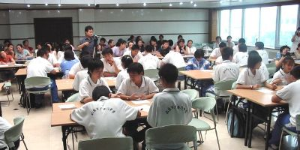
The busy day started in a superbly equipped seminar room in the school where Keith began his rockets lesson with students from the High School Affiliated to Beijing Normal University with and their teacher April Dong.
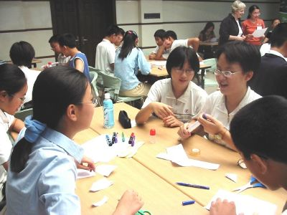

Keith explained basic ideas behind rocket design, and that there would be a prize for the best design, flight and presentation of rockets. Students were asked to consider factors which might effect the success of their launch and flight such as rocket design, length, gluing and wings/fins.
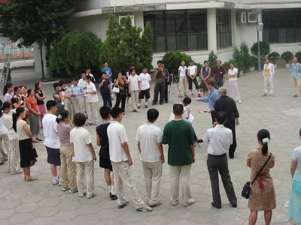
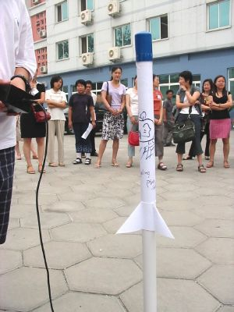

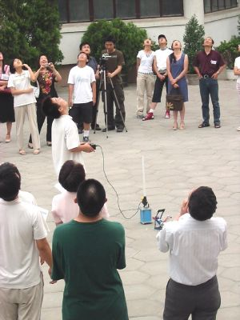

After the practical activity of building rockets, the 7 groups of students and teachers went outside into the school yard, in the blazing heat, to begin the launching.

Wonderfully, the first rocket explodes and all the others soared high into the sky to gasps and the delight of the audience gathered.
Back inside students prepared their presentations within a limited time and they were offered support sheets and frames with structures and phrases to help them do this. The students gave very good presentations making use of models and schematic drawings on the OHP.
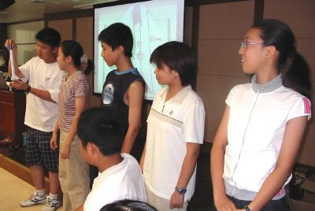
The judges’ decision was very difficult. Prizes donated by the Cultural and Education Section of the British Embassy in Beijing of a copy of Nick Park’s ‘A Grand Day Out’ and a copy one of the Horrible Science book series were presented to the winners.
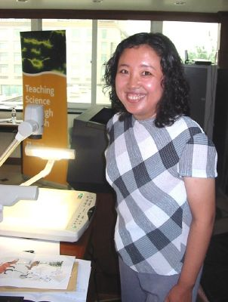
Lesson 2
After these students had left another group arrived from the host school for a second demo lesson in Biology from a colleague, Helen, who taught students ‘Energy Flow in an Ecosystem’ where students worked in groups to visualise the stages and levels of the food chain. We learnt a lot about the importance of using diagrams and visuals for supporting language development in bilingual Science.
Helen followed this lesson up by taking questions from the teachers on the risks and benefits of teaching through the medium of English.

After lunch…
We picked up again on some of the points raised in the discussion before lunch and looked in more detail at some of the significant aspects of the lessons, which had been video recorded for this purpose and which CES intend to use for further teacher development in Science and ELT. The themes we focused on included: the language of instructions, supporting students’ language in making presentations, and setting up and managing group work.

Finally…
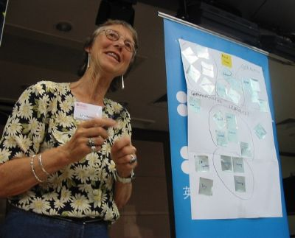
We evaluated the day by carrying out an ‘argument cluster’ activity that gave us some useful feedback on what participants valued about the day, and what they would like to see in a future workshop, such as the teaching methods, practical activities and access to resources.
The day ended with a thunderstorm and flooding. After waiting for some time ‘we’ found a taxi that drove us through the submarine section of the city. Together with Helen, Xioadan from the CES and colleagues we enjoyed a joyful dinner in nice surroundings in restaurant Kè Jía on Lake Kè Jía Jǐu Lóu as it continued to rain!

A great start to a weekend of ‘Celebrating Science’!

Day 2 – Sunday July 11 2004

Chemistry in our Lives: Workshop on Cosmetics
Number 4 High School, Beijing, China
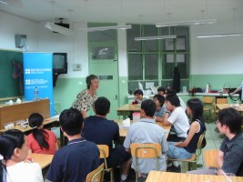

A day of science celebration took place in Beijing, China yesterday, Sunday 11th July, as 3 workshops were carried out on cosmetics within the Teaching Science through English project of the British Council in China.

60 students and teachers came together over the day working in small groups to produce their own range of hair gels, shampoos, and bath salts in a limited time, creating an image and a brand for their products which they were asked to present to the group towards the end of the workshop. The British Council offered Science books for young people as prizes for the group which produced the best cosmetics and offered the most convincing pitch for their product. It was all done through the medium of English.
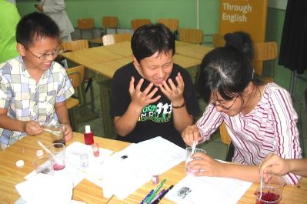

I had the privilege of assisting Lida during the workshops and eventually lost my sense of smell and got used to the strong whiff of perfume that had saturated the air in the classroom over the 5 hours or so that we worked.

I expected the presentations to cause difficulties, but was impressed with the enthusiasm of the students for the presentations, as well as their ability to put together a presentation outlining the main characteristics of their products and manage a bit of sales patter as well ‘our first customer will receive a free gift’.
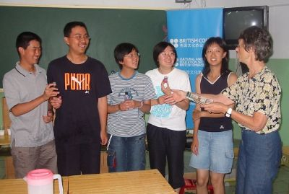

We had hair gel with the brand name ‘Transfiguration’, and the bath salts called ‘Miracle’, or the products from the ‘Gobblin’ brand for children who want to make themselves look particularly horrible for Halloween, and there was the line of products moulded around the concept of the elements to reflect images of water, earth, and nature.
It was a Sunday and after the last day of the school year on Friday it was great to have so much enthusiasm for an extra day’s work, for the students and their teachers especially after what felt like it must have been a tropical storm had caused so much havoc with traffic and house damage for families and colleagues in Beijing and beyond.

The presentations were excellent and the teachers clearly enjoyed being able to join in as well, though we made them beg first!

Final words…

The British Council is doing a lot of work in Science and ELT with its programme ‘Teaching Science in English’ and its Science Summer Camps for teachers, not to mention the very successful school links that have been developed through the Science Across the World programme (www.scienceacross.org), especially with schools in Shanghai and the UK. You can find lots of ideas like the Rocket building and cosmetics workshop at the Science Across the World website, and the FACTWorld website (www.factworld.info). Lida and I have been working on a new project which we hope we will be able to bring back to the wonderful colleagues and students we met over these two days, and that is the IUPAC and GSK funded Young Ambassadors of Chemistry project where we will be offering Science Celebration Days around the world with the help of young people and their teachers (an outline of the project is online at http://www.iupac.org/projects/2003/2003-055-1-050.html).

It’s always a pleasure to be in China and I hope we can come back soon!
Keith and Lida

