ZCC campaign, Shanghai, October 2005
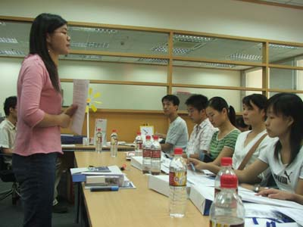
The campaign got underway with a morning of training for exhibition facilitators at the offices of the British Council in Shanghai. 32 students from the Maritime University in Shanghai came along to volunteer to facilitate the workshops and help with the running of the exhibition generally.

Xu Ying gets the training under way…

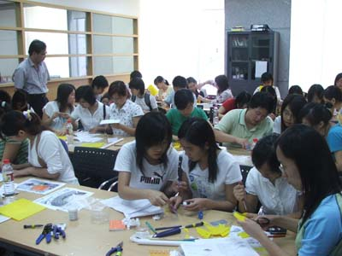

The training focused on practising MUTR kit construction www.mutr.co.uk.

The students were a delight to work with for their enthusiasm and creativity building Mickey Mouse faces, boats, planes and all manner of ‘gismos’ not to mention the solar-powered clocks, windmills and UV-warning badges.

The workshops was followed up with an interview at NetEase @163.com, Shanghai. The interview began with questions around the ZCC campaign and exhibition and then the ‘listeners’ chipped in with so many questions that there was little room for any of the planned agenda of discussion. Many of the questions given with such understanding of the issues related to Climate Change that I openly admit that they were beyond my own layperson’s knowledge. A number of browsers didn’t manage to put their questions as we ran out of time.

Questions related to the number of fridges beying used in China and possible consequences for the ozone layer; some participants discussed the growing wealth in Shanghai and the relationship this has with environmental problems; ‘environment’ was linked with the increasing number of dogs in the city and responsibility owners had for the mess they make; how can we, Shanghainese, equate the increase in cars in the city with out responsibilities to the environment?’; and similarities between London and Shanghai in terms of Climate Change were also mentioned among many many other issues.

The Shanghai Science and Technology Museum was the venue for the exhibition and wrap-around activities and I contributed to the first 5 days of the event. At several spot counts we had around 100 people working with us and watching on, nosey to find out what all the commotion was about and of course that was the whole point! The museum managers told us that they were expecting around 10,000 visitors per day given that we were working over the China National Day holidays.

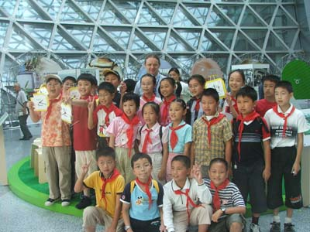
After a grand opening, the Dongmen Primary School children from Chongming Island came and participated in the first wrap-around workshop, their art work decorating the exhibition area.

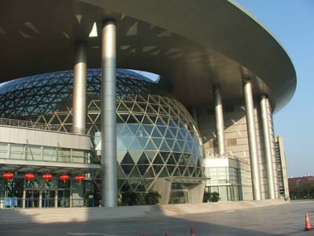
The magnificent building of the Shanghai Science and Technology Museum, our host venue.

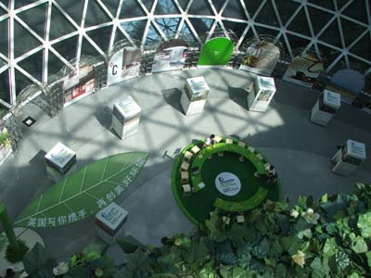

The exhibition area was a great place to work for the week.

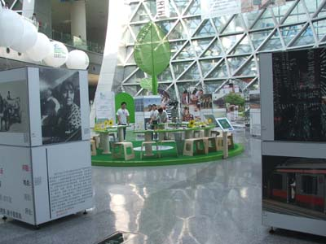

Media coverage for the event was constant, everyday there appeared photographers and journalists eager to report what was going on and understand the concept behind the exhibition and wrap-around activities.

The aim was to offer practical activities for children and their parents to attract attention to the exhibition through related themes such as solar power and wind energy as well as UV radiation.

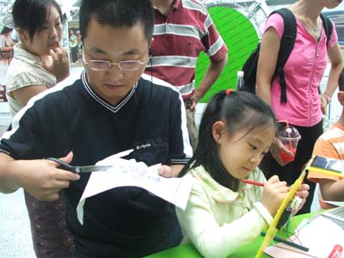

Father and daughter…

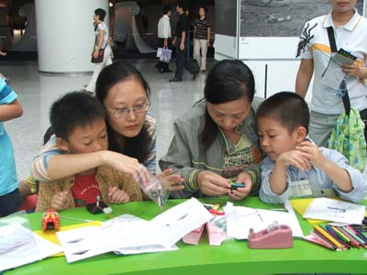

Mothers and sons…

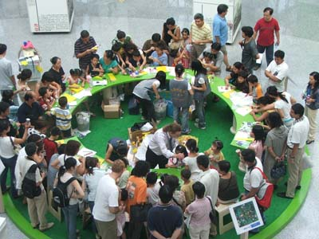
We certainly attracted attention!

The range of inventions and gismos was enormous!
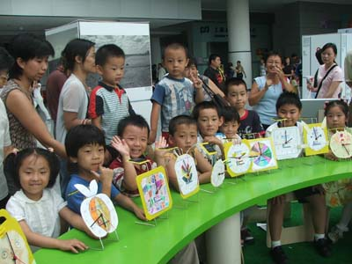

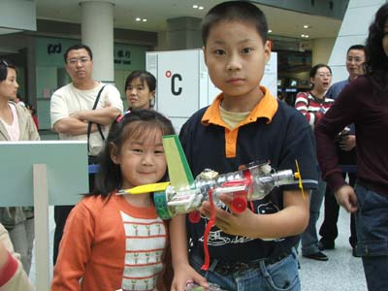

planes…

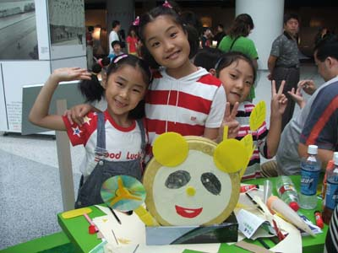

Chinese panda…

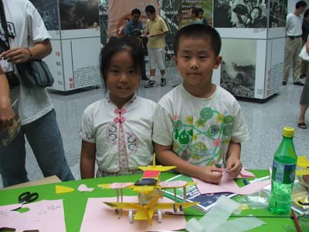

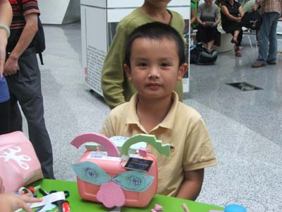
planes were popular…

a radio…

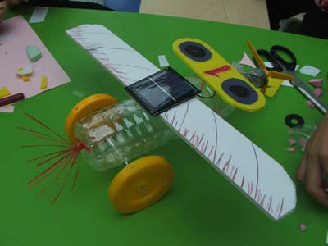

super buggy…

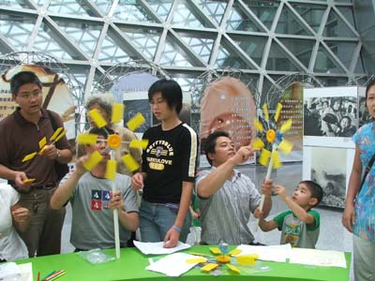

wind turbines…

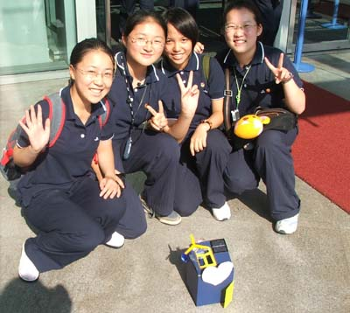

solar house…

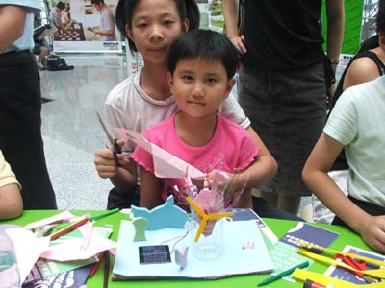

solar peacock…

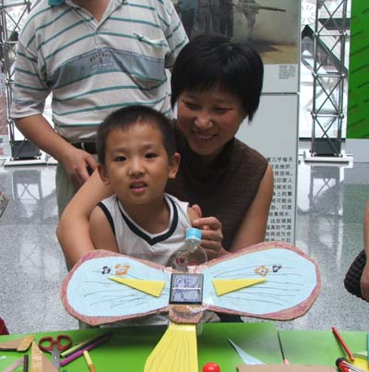

solar bird…

We also offered an artists’ corner for children to create drawings using the photochromic uv-sensitive paint.

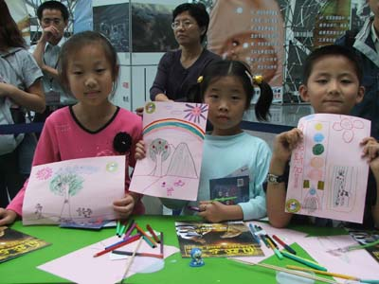
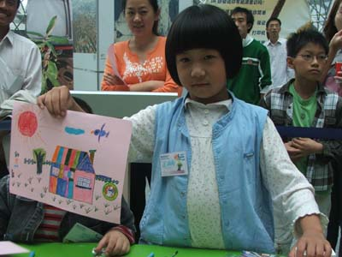

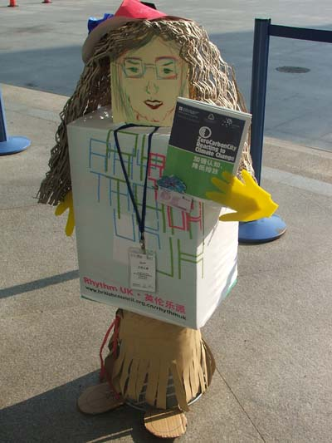
We needed an extra pair of hands, ZeeCee (ZC = Zero Carbon) came to our rescue!

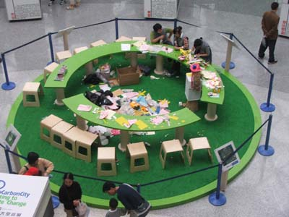

The place was like a bombsite after each session (very much a sign of productive work taking place, in my opinion) and I should like to thank the facilitator volunteers from the Shanghai Maritim University for there hard work and commitment to the event.


Some couldn’t take the pace…

It was a truly unforgettable experience!

Many thanks to all the people who made it possible, I hope I can do it again sometime in the not-too-distant future!
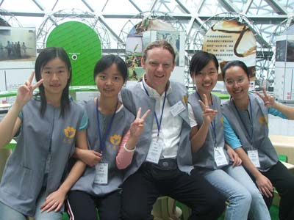
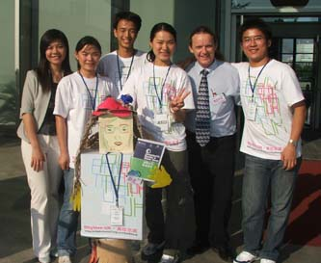
Best wishes

Keith

Keith Kelly (Language Education Consultant)
FACTWorld Coordinator (www.factworld.info)
NILE Associate Trainer (www.nile-elt.com)
SAW Consultant (www.scienceacross.org)

Home address: 20 Rose Valley, Norwich, NR22PX, UK
Home tel: 0044 1603610896

Mobile: 0044 778 2356776
email: keithkelly@factworld.org

The Forum for Across the Curriculum Teaching - Supporting and Developing Content and Language Integrated Learning

