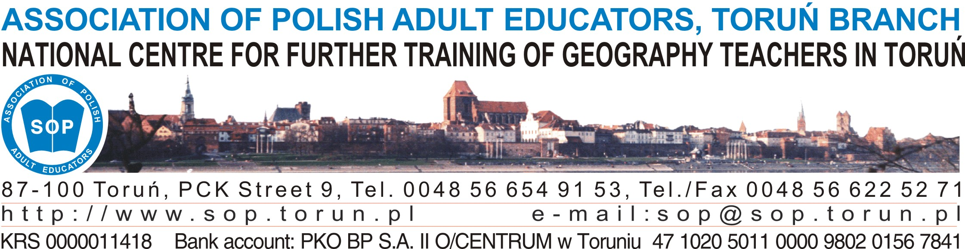

Toruń, 15 May 2013

INVITATION
The Association of Polish Adult Educators in Toruń and the Association of European Geographers EUROGEO are happy to announce the 8th edition of the international methodology workshop:
Tools for cross-curricular education
in bilingual Geography and History
Toruń, Poland, 4–6 October 2013

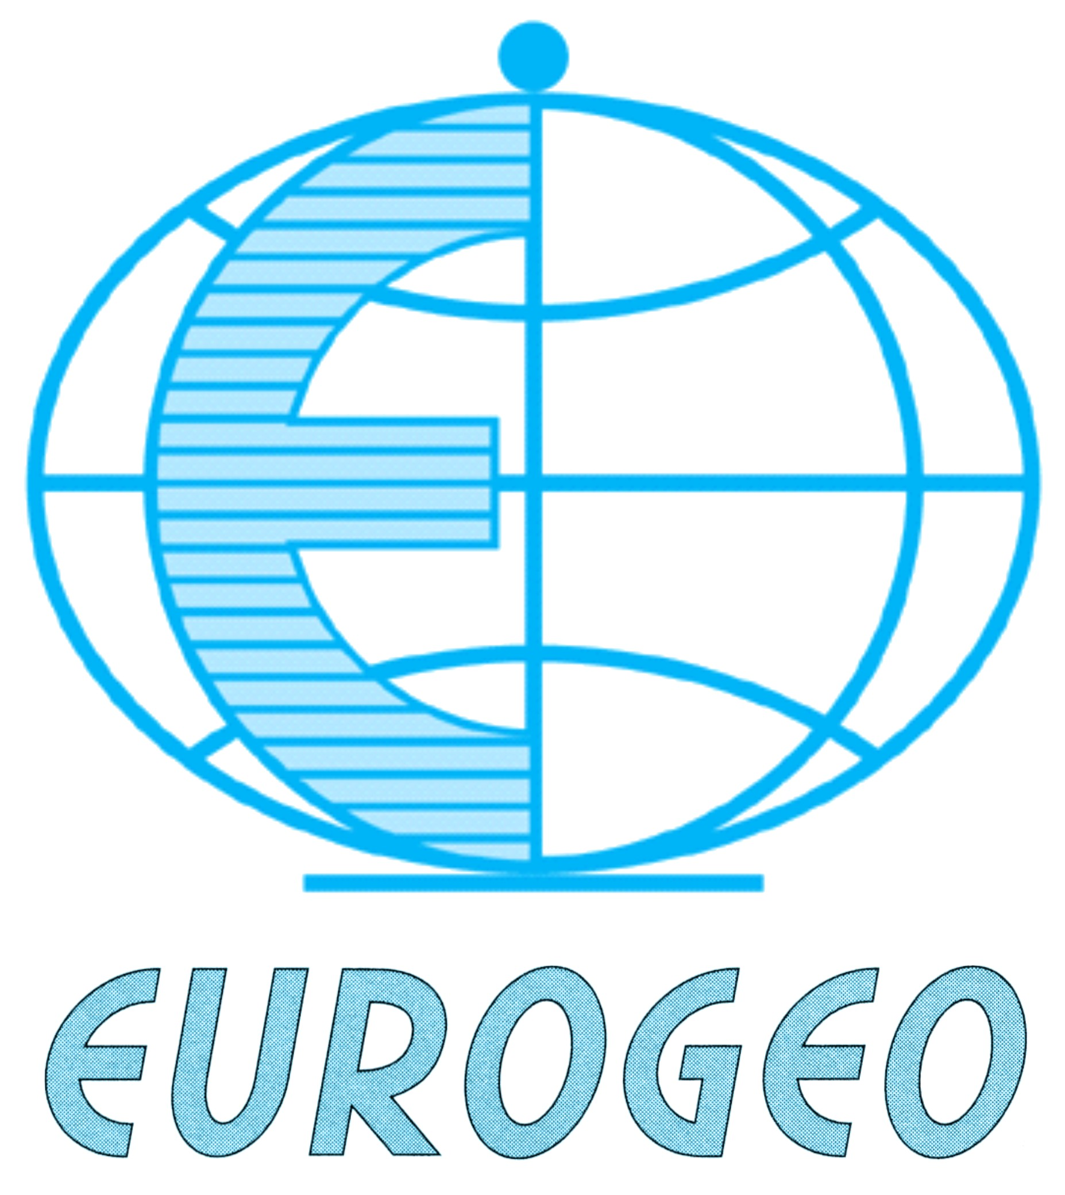
patronage
The meeting is organised under the patronage of EUROGEO, the Association of European Geographers.

Workshop participants
The workshop is dedicated to teachers who teach Geography or History in English, especially those for whom English is not their mother tongue.
Workshop leaders
- Katarzyna Papaja – University of Silesia, Institute of English, Poland
- Charles Wielgus Barry – Meridian International School of Warsaw, Poland
- Aleksandra Zaparucha – Association of Polish Adult Educators in Toruń, Poland

Workshop venue

The National Centre for Further Training of Geography Teachers in Toruń, 9 PCK Str., Poland

The aims of the Workshop

The meeting is a great occasion for:
- bringing bilingual teachers together
- exchanging best practices connected with bilingual education
- gaining a wider perspective of bilingual teaching in the world
- getting some input and useful techniques
- discussing didactical resources available
- networking with one another.

Annex 1

WORKSHOP PROGRAMME*

Tools for cross-curricular education

in bilingual Geography and History
bilingual EUROGEO* workshop, toruń, october 4-6, 2013

Workshop leaders
- Katarzyna Papaja – University of Silesia, Institute of English, Poland
- Charles Wielgus Barry – Meridian International School of Warsaw, Poland
- Aleksandra Zaparucha – Association of Polish Adult Educators in Toruń, Poland

FRIDAY, 4 OCTOBER 2013
14.30–15.15 | Registration at the National Centre for Further Training of Geography Teachers, 9 PCK Str., once you have checked in at:  - Hotel Uniwersytecki, 83 Szosa Chełmińska Str.
15.15–15.30 | Opening and welcome speech  Antoni Stark – the Head of the Association of Polish Adult Educators in Torun
15.30–16.15 | Ice–breaker |  | Aleksandra Zaparucha  Seven Cs of the 21st century education
16.15–17.15 | Presentation |  | Katarzyna Papaja  Bilingual education in Poland and beyond – an overview
17.15–17.30 | Coffee break
17.30–19.15 | Parallel sessions:  presentations |  | Session 1 |  | Session 2
17.30–19.15 |  |  | Richard Bolt  Aleksandra Zaparucha Geography textbook and workbook: componenets, translation and usage |  | Charles Wielgus Barry  Materials to teach History bilingually  (including the new History textbook)
19.30–??? | Welcome dinner at the National Centre
SATURDAY, 5 OCTOBER 2013
8.00–9.30 | Workshop |  |  | Aleksandra Zaparucha  An integrating lesson of Geography and History
9.30–9.45 | Coffee break
9.45–12.00 | Workshop |  |  | Aleksandra Zaparucha  Step 1 – Integrated curriculum – lesson preparation
12.00–13.30 | Workshop |  |  | Aleksandra Zaparucha  Step 2 – Integrated curriculum – lesson presentation
13.30–13.45 | A coach to the Academic Canteen (1/3 Słowackiego Str.)
13.45–14.15 | Lunch
SATURDAY, 5 OCTOBER 2013
14.15–14.30 | Walk to the city centre
14.30–15.00 | Visiting Tony Halik Traveller’s Museum (11 Franciszkańska Str.)
15.00–16.30 | Fieldwork | Cross-curricular fieldwork (Old Town Market)
16.30–17.00 | Free time
17.00–19.20 | Tools for cross-curricular education in bilingual Geography and History – Best practice. Selected presentations given by participants (20 min each)
19.30– ??? | Farewell dinner at the National Centre
SUNDAY, 6 OCTOBER 2013
9.00–10.00 | Workshop:  Supporting Learning in Bilingual Education |  | Charles Wielgus Barry  Why learn and teach bilingually – a few remarks
10.00–11.00 |  |  | Katarzyna Papaja  Supporting language in bilingual education
11.00–11.30 |  |  | Aleksandra Zaparucha  Final plenary
11.30–11.45 | Evaluation of the workshop (closing remarks)
11.45–12.00 | Certificates and Plenary farewell
afternoon | Participant depart
* EUROGEO – links European Geography teacher associations.
Keep in touch with EUROGEO at www.eurogeography.eu
* The workshop programme is viable to change once the organizers get all the presentations from the participants

Language

The language of the Workshop is English. No translation of the presentations will be possible.

Registration fee
Registration FEE
EUROGEO members | 140 Euro
Others | 160 Euro

The registration fee covers:
- organisation costs
- a copy of workshop materials
- a copy of the book of proceedings
- refreshments, breakfasts, lunches and dinners
- accommodation on October 4th/5th and 5th/6th
- visiting Tony Halik’s Travellers Museum.

Registration deadline

The Registration Form (see Annex 2) should be completed and sent to the workshop Organiser (marcin.stark@sop.torun.pl) no later than 15th September 2013 together with the theme of a presentation.
Note that delivering a presentation is not obligatory.
The fee should be sent by bank transfer till 15th September 2013 to the following account:
Account Holder:
Stowarzyszenie Oświatowców Polskich, Oddział w Toruniu, Polska (in Polish)
Association of Polish Adult Educators, Toruń Department, Poland (in English)
BANK: PKO BP S.A. II/O Centrum w Toruniu
IBAN: PL 47 1020 5011 0000 9802 0156 7841
SWIFT: BPKOPLPW

The title of the bank transfer should contain the words TORUN WORKSHOP 2013 and the name and surname of the participant.

participant’s questionNaire
Each participant is also kindly requested to fulfill and return the Participant’s Questionnaire (see Annex 3).

Publication
Papers based on the participants’ presentations will be published in the book of proceedings.
Papers will be collected during the registration (CD).
The file should include: the title, name, affiliation, e-mail address.
The paper should not exceed eight A4 pages (including References).
General requirements are the following:
- MS Word for Windows
- Title bold, 12 point
- The name(s) of the author(s) in the form "family name and initials", in 12 point, bold
- Affiliation with a complete postal address, 12 point, italics
- If affiliations of the co-authors are not the same, they should be listed in succession
- The e-mail address of the corresponding author, 10 point, italics
- Abstract and key words (up to six), 10 point
- Main text: Font Times New Roman12 point, 1.5 spacing, tabulation 0.5 cm
- Photos and figures (both of good quality) should be inserted directly in the Word file.

LOCATION
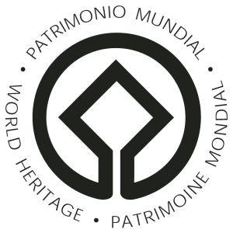
The city of Toruń is located in Central Poland, about 200 km from Warsaw in the west-north direction. It is a co-capital of the Kuiavian-Pomeranian Voivodeship (province). The population of the city is about 205,000.
Toruń is a popular tourist destination because of its history and marvellous gothic architecture.
In 1997 the Medieval Town of Toruń was included in the UNESCO World Heritage List.

TRANSPORTATION
The nearest airport is located in Bydgoszcz (Paderewski Airport) – only 1 hour away from Toruń by train or bus.
Toruń is also easy to reach:
- from Poznan (Lawica Airport) - a 2.5-hour train journey
- from Warsaw (Chopin Airport) – a 3-hour train journey
- from Gdansk (Lech Walesa Airport) – a 4-hour train journey


ACCOMMODATION
All workshop participants will be accommodated in the Hotel Uniwersytecki on 4th and 5th October 2013 (breakfast and WiFi access included). All those wishing to book extra accommodation are requested to give some details in the Registration Form.
The hotel is located close to the workshop venue (about 700 metres away) and about 1.5 km away from the Torun Old Town area (see map in Annex 4).

QUESTIONS

More details concerning the meeting will be provided in the next circular to all those who register.

Queries regarding the workshop can be sent to marcin.stark@sop.torun.pl
With best regards

Secretary of the Workshop

Marcin Stark
marcin.stark@sop.torun.pl

Annex 2

REGISTRATION FORM
Tools for cross-curricular education in bilingual Geography and History
BILINGUAL EUROGEO WORKSHOP, Torun, 4–6 October 2013
Final registration – 15th September 2013

First  name |  |  |  | Family name
Biodata
(up to 50 words)
Institution name
Country
City
Street
ZIP
The Institution’s Tax Number
(if the Invoice is needed)
E-mail
Title of presentation
Equipment required
Accommodation during the Workshop  (please cross out if not needed) |  |  |  | Extra accommodation needed (paid extra by the participant at the hotel)
4th/5th October |  | 5th/6th October
Payment:  bank transfer only  (please leave only the option you choose and cross out the second one) |  | EUROGEO members |  | 140 EURO
 |  | Others |  | 160 EURO

Annex 3

participant’s questionNaire

I. School or university (tick  in the right box)
 primary school |  |  |  |  |  |  |  middle school |  high school |  university
 state |  |  |  |  |  |  |  private

II. Teacher

1. Qualifications
 |  |  |  |  |  | subject specialist with good language skills
 |  |  |  |  |  | English teacher with a good knowledge of a subject
 |  |  |  |  |  | subject teacher and English teacher
 |  |  |  |  |  | subject & foreign language taught by two specialists (team teaching)
 |  |  |  |  |  | other (givedetails In the space provide):

2. Language skills
 |  |  |  |  |  | Cambridge First Certificate (or equivalent)
 |  |  |  |  |  | Cambridge Advanced English (or equivalent)
 |  |  |  |  |  | Cambridge Proficiency English (or equivalent)
 |  |  |  |  |  | Teacher Training College
 |  |  |  |  |  | Bachelor Degree
 |  |  |  |  |  | Master Degree

3. Methodology qualifications for foreign language teaching (give details)

……………………………………………………………………………………………………………………………………………………………………………………………………………………………………………………………………………………………………………………………………………………………………………………………………………

…………………………………………………………………………………………………………………………………………………………………………………………………………………………………………………………………………………………………………………………………………………………………………………………………………..

4. Methodolody qualifications for school subject teaching (give details)

……………………………………………………………………………………………………………………………………………………………………………………………………………………………………………………………………………………………………………………………………………………………………………………………………………

…………………………………………………………………………………………………………………………………………………………………………………………………………………………………………………………………………………………………………………………………………………………………………………………………………..

5. Foreign languages used in bilingual education in your school
 |  |  |  |  |  | English
 |  |  |  |  |  | German
 |  |  |  |  |  | French
 |  |  |  |  |  | others

6. School subjects taught bilingually
 |  |  |  |  |  | Geography
 |  |  |  |  |  | Biology
 |  |  |  |  |  | Physics
 |  |  |  |  |  | Chemistry
 |  |  |  |  |  | Mathematics
 |  |  |  |  |  | others (give details in the space provided):

7. Model of bilingual teaching
 |  |  |  |  |  | solely in foreign language
 |  |  |  |  |  | partly in a foreign language and partly in mother tongue (give % in a foreign language) |  |  |  |  | %
 |  |  |  |  |  | other – (give details in the space provided): VERTE

8. Materials used during classes
 |  |  |  |  |  | teacher-produced (tick percentage): 20 40 60 80 100%
 |  |  |  |  |  | foreign textbooks (give authors, titles and publishers):

………………………………………………………………………………………………………………………………………………………………………………………………………………………………………………………………………………………………………………………………………………………………………………………………………….

………………………………………………………………………………………………………………………………………………………………………………………………………………………………………………………………………………………………………………………………………………………………………………………………………….
 |  |  |  |  |  | other textbooks (give authors, titles and publishers):

………………………………………………………………………………………………………………………………………………………………………………………………………………………………………………………………………………………………………………………………………………………………………………………………………….

………………………………………………………………………………………………………………………………………………………………………………………………………………………………………………………………………………………………………………………………………………………………………………………………………….
 |  |  |  |  |  | electronic sources (give websites):

………………………………………………………………………………………………………………………………………………………………………………………………………………………………………………………………………………………………………………………………………………………………………………………………………….

………………………………………………………………………………………………………………………………………………………………………………………………………………………………………………………………………………………………………………………………………………………………………………………………………….
 |  |  |  |  |  | others (give details):

9. Testing
 |  |  |  |  |  | solely in a foreign language
 |  |  |  |  |  | partly in a foreign language (give %): 0-20 20-40 40-60 60-80 80-100%
 |  |  |  |  |  | solely in a mother tongue

10. Grading
 |  |  |  |  |  | solely the subject knowledge
 |  |  |  |  |  | both the subject and the foreign language knowledge (give % in a foreign language) |  |  |  | %
 |  |  |  |  |  | others (give details in the space provided):

III. Students

1. Selection based on results of
 |  |  |  |  |  | a language test
 |  |  |  |  |  | an interview
 |  |  |  |  |  | both language test and an interview
 |  |  |  |  |  | others (give details in the space provided):

IV. Bilingual teacher’s experience

1. Participation in the following events (name, year, organizer):
 |  |  |  |  |  | bilingual methodology workshops
 |  |  |  | ………………………………………………………………………………………………………………………………………………………………………………………………………………………………………………………………………………………………………………………………………………………………………………………………………….
 |  |  |  |  |  | bilingual post-graduate courses
 |  |  |  | ………………………………………………………………………………………………………………………………………………………………………………………………………………………………………………………………………………………………………………………………………………………………………………………………………….
 |  |  |  |  |  | bilingual international conferences (in Poland and/or abroad)
 |  |  |  | ………………………………………………………………………………………………………………………………………………………………………………………………………………………………………………………………………………………………………………………………………………………………………………………………………….

V. Bilingual teacher’s needs

1. I would like to take part in the following events:
 |  |  |  |  |  | bilingual methodology workshops (in Poland and/or abroad)
 |  |  |  |  |  | bilingual post-graduate courses
 |  |  |  |  |  | bilingual international conferences (in Poland and/or abroad)

VI. Topic suggestions and proposals for next event, please!

…………………………………………………………………………………………………………………………………………………………………………………………………………………………………………………………………………………………………………………………………………………………………………………………………………..

…………………………………………………………………………………………………………………………………………………………………………………………………………………………………………………………………………………………………………………………………………………………………………………………………………..

Annex 4

