Writing frames - Writing a comparison
Comparing: historical events/periods, biological phenomena, populations in geography
Description 1 | conjunctions for making comparisons  Unlike (item 1), (item 2) is … / Like (item 1), (item 2) …  A similarity / difference between (item 1) and (item 2) is …  (item 1) is … whereas (item 2) is …  (item 1) is …. Similarly, (item 2) is …  (item 1) and (item 2) are alike / similar because they share / both have …  Where / While (item 1) is … (item 2) is …  (item 1) and (item 2) are different because while / where (item 1) is …, (item 2) is …  Another way in which (item 1) is similar to / different from (item 2) is …  (likewise, neverthless, however, in contrast, despite, but, yet, on one hand … on the other …, also, too, even though, although)  comparative / superlative adjectives express differences between two items  (item 1) is bigger / smaller than (item 2),  (item 1) has the biggest / smallest …  The bigger the … , the more the …  (item 1) has less … than (item 2)  (item 1) is not as big as (item 2)  verb phrases for comparing / contrasting two items  The … in (item 1) are similar to / different from the … in (Item 2)  The … in (item 1) resemble / differ from the … in (item 2) in terms of … | Description 2
(notes/statements about item 1)  It is … (description) / It has … (description) / It shows … (description) / It does … (function) / It is located … (location) / It is made up of … (structure) |  | (notes/statements about item 2)  It is … (description) / It has … (description) / It shows … (description) / It does … (function) / It is located … (location) / It is made up of … (structure)
Similarities |  | differences
(common/shared characteristics) |  | (distinctive features/differences)

Draw conclusions from your comparison
This comparison shows…
We can see that …
It can be said that …
For the most part …
As a result …
In summary …
We can conclude that …
It can be concluded that …
This means (that) …

For more language on comparisons:
http://www.onestopenglish.com/clil/clil-teacher-magazine/your-clil/comparisons/
For more language on conclusions and findings:
http://www.onestopenglish.com/clil/clil-teacher-magazine/your-clil/conclusions-and-findings/
Writing frames - Writing a comparison
Visuals for comparisons can also be used to help support writing

Venn Diagram  list characteristics of item 1  list characteristics of item 2  list shared characteristics  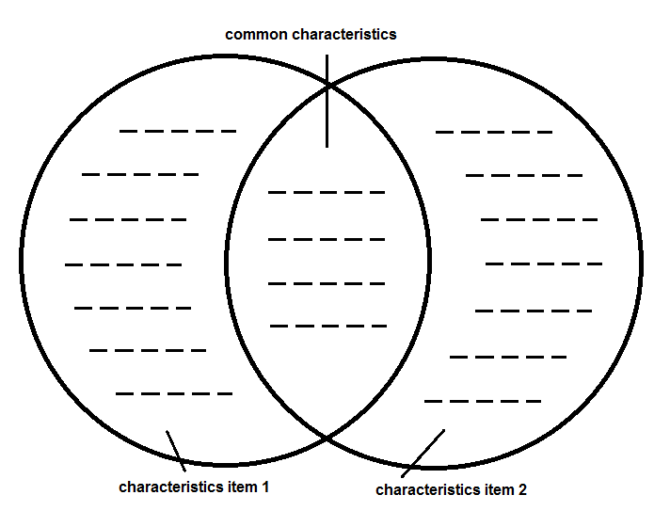 | put language support in separate sections

Table  give items in columns  give characteristics in rows | put language support on borders

Illustrations  give characteristics as labels | put language support between two images

